HYBRID LEARNING AND TRAINING EFFECTIVENESS AT UNION BANK OF INDIA
PROJECT REPORT
Submitted by
Ms. Sreetama Ghosh Ray
(Register No: 251578222039)
In partial fulfilment of the requirement for the award of the Degree
MASTER OF ARTS IN
HUMAN RESOURCE MANAGEMENT
Under the guidance of
Dr. E. T. EVANGELINE, MBA, M.Phil, Ph.D.
Head of the Department

P.G. DEPARTMENT OF HUMAN RESOURCE MANAGEMENT
MADRAS SCHOOL OF SOCIAL WORK
(AUTONOMOUS)
No. 32, CASA MAJOR ROAD, EGMORE
CHENNAI – 600008
OCTOBER 2026

BONAFIDE CERTIFICATE
This is to certify that the project titled “HYBRID LEARNING AND TRAINING EFFECTIVENESS AT UNION BANK OF INDIA” is a bonafide project work done by Ms. Sreetama Ghosh Ray (Reg No: 251578222039), a second year student of M.A. HRM, Madras School of Social Work (Autonomous), Egmore, Chennai in partial fulfilment of the requirement for the Award of the Degree of Master of Arts in Human Resource Management and that the project has not been used previously for the award of any Degree, Diploma, Scholarship, Fellowship or any other project title.
Signature of the Guide Signature of the HOD

DECLARATION
I, SREETAMA GHOSH RAY, final year student of M.A. HRM hereby declare that the thesis entitled “HYBRID LEARNING AND TRAINING EFFECTIVENESS AT UNION BANK OF INDIA” is the original work done by me under the guidance and supervision of Dr. E. T. EVANGELINE, in partial fulfilment of the requirements for the award of the degree of Master of Arts in Human Resource Management, Madras School of Social Work. I further declare that the research work has not been submitted at any other University or Institution, for the award of any degree or diploma or fellowship.
Signature of the Guide Signature of the Student
PLACE: CHENNAI
DATE: October 2026

ACKNOWLEDGEMENT
I am grateful to Dr. J. S. Gunawathy, Principal-in-Charge, Madras School of Social Work, for her support throughout my M.A. Human Resource Management programme. I sincerely thank my Head of Department and guide, Dr. E. T. Evangeline, for her guidance, thoughtful feedback, and encouragement while I developed and completed this thesis.
I thank Ms. Devi Kumar and Ms. Karthiga, senior HR officers at Union Bank of India, Regional Office Chennai South, for helping me approach branches and complete my fieldwork. I also thank Mr. Sayantan Mahalanobis, HR L&D Division, Union Bank of India, for his support. I am grateful to Mrs. Sharada Devi, Regional Head, Chennai South, for her mentorship and guidance during my internship. My thanks go to the officials and employees of the Regional Office and the branches I visited for their time, cooperation, and participation in the survey.
I am deeply grateful to my father, Mr. Syamal Ghosh Ray, former General Manager, Union Bank of India (erstwhile Andhra Bank), for sharing his experience of banking before and after the 2020 amalgamation. I also thank Mr. Vikas Babu Chittiprolu, General Manager – Operations, Union Bank of India, Head Office, Mumbai, for his insights into the Bank’s post-merger operations and learning initiatives. I thank Ms. Sumitra R, former Chief Manager, Bank of Baroda, for her support and guidance on banking practices, and Mr. Debanjan Mondal, Senior Manager, Standard Chartered Bank, for sharing his practical perspective on changing training practices in banking.
Their support helped me complete this research and made the experience an important part of my academic and professional learning.

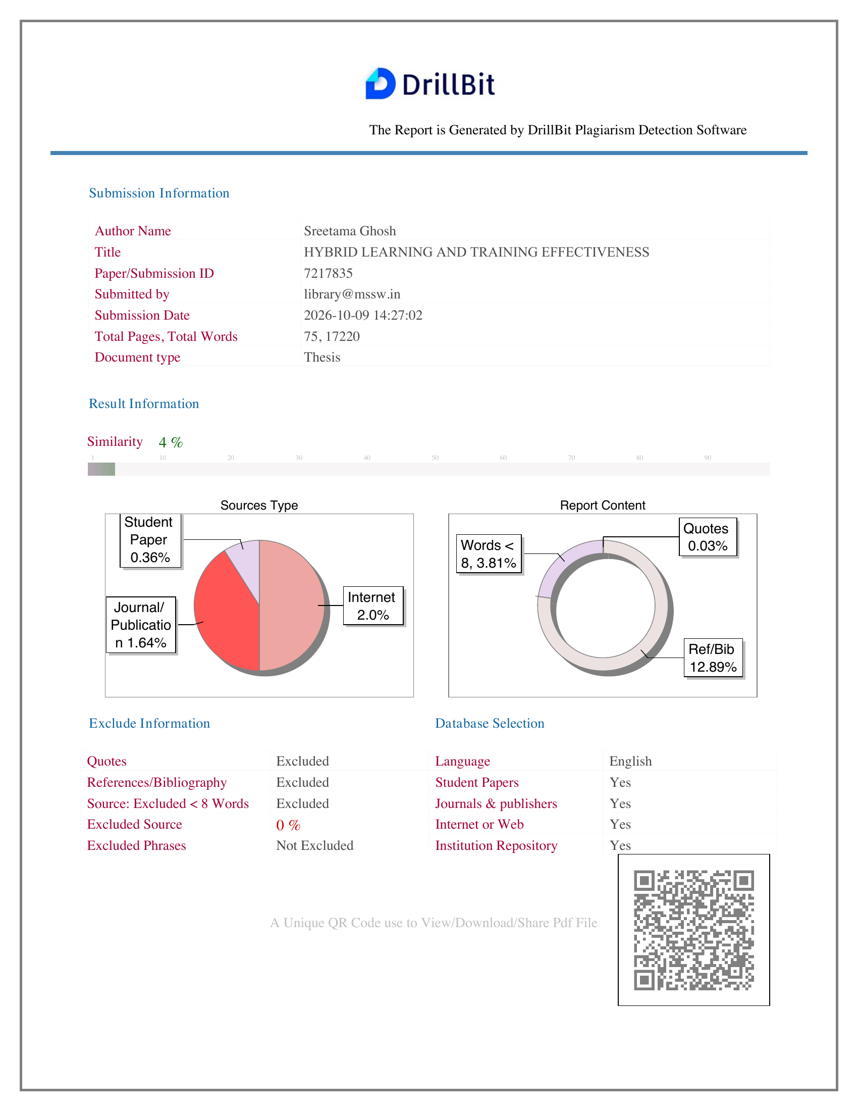

TABLE OF CONTENTS
CHAPTER TITLE PAGE NO
1 INTRODUCTION 11
1.1 Background and Context 11
1.2 Key Concepts and Definitions 13
1.3 Need, Scope and Significance of the Study 15
1.4 Statement of the Problem 17
1.5 Research Questions 17
1.6 Industry and Company Context 17
1.7 Chapterisation 19
2 REVIEW OF LITERATURE 21
2.1 Review of Relevant Literature 21
2.2 Theoretical Framework 30
2.3 Case Study: Union Bank of India 32
2.4 Gaps in the Study 33
3 RESEARCH METHODOLOGY 36
3.1 Objectives of the Study 36
3.2 Hypothesis of the Study 36
3.3 Definition of Variables 37
3.4 Research Design 38
3.5 Population, Sample and Sampling Method 39
3.6 Data Collection Procedure and Screening 40
3.7 Research Instrument and Scoring 41
3.8 Research Questions 42
3.9 Data Analysis Techniques 42
3.10 Questionnaire Review, Reliability and Validity 45
3.11 Ethical Considerations and Limitations 46
4 DATA ANALYSIS AND INTERPRETATION 48
4.1 Descriptive Analysis 48
4.2 Inferential Analysis 61
4.3 Interpretation of Results 66
4.4 Comparison with Previous Studies 67
4.5 Theoretical and Practical Implications 68
5 SUMMARY, CONCLUSION AND SUGGESTIONS 70
5.1 Introduction 70
5.2 Summary of the Study 70
5.3 Major Findings 71
5.4 Contribution of the Study 73
5.5 Suggestions for Training Review 73
5.6 Limitations of the Study 76
5.7 Directions for Future Research 76
5.8 Conclusion 77
REFERENCES 78
APPENDIX A — QUESTIONNAIRE 82
Hybrid Learning and Training Effectiveness at Union Bank of India 82
Section A — Eligibility and Basic Information 82
Response Scale for Questions 5–30 82
Section B — Hybrid Learning 83
Section C — Trainer Competence 83
Section D — Learner Engagement 83
Section E — Training Effectiveness 84
APPENDIX B — QUESTIONNAIRE DEVELOPMENT AND LITERATURE BASIS 85

LIST OF TABLES
Table 2.1: Literature supporting the present study 29
Table 3.1: Regression hypothesis 37
Table 3.2: Construct operationalisation and item allocation 38
Table 3.3: Response disposition and SPSS analysis cases 40
Table 3.4: SPSS-based analysis plan 43
Table 4.1: Respondent profile frequencies (N = 102) 48
Table 4.2: Construct-level descriptive statistics from SPSS Explore output 51
Table 4.3: Hybrid Learning item means 52
Table 4.4: Item response frequencies for the 102-case scored dataset 54
Table 4.5: Overall questionnaire consistency 61
Table 4.6: Pearson correlations among study constructs 61
Table 4.7: Overall multiple-regression model 63
Table 4.8: Predictor coefficients for Training Effectiveness 63
Table 4.9: One-sample comparisons with the neutral midpoint, 102-case scored CSV 64
Table 4.10: Paired comparisons with Training Effectiveness, 102-case scored CSV 65
Table 4.11: Chi-square crosstab suitability check, 102-case scored CSV 66
Table 5.1: Decision on the overall regression hypothesis 72
Table 5.2: Individual predictors in the combined regression model 72
Table 5.3: How the findings inform the proposed training review 74
Table B.1: Literature basis for Hybrid Learning questions 85
Table B.2: Literature basis for Trainer Competence questions 87
Table B.3: Literature basis for Learner Engagement questions 88
Table B.4: Literature basis for Training Effectiveness questions 89

LIST OF CHARTS
Figure 4.1: Age-group distribution 50
Figure 4.2: Length-of-service distribution 50
Figure 4.3: Job-level distribution 50
Figure 4.4: Mean ratings for the four study constructs 52
Figure 4.5: Hybrid Learning item-response distribution 57
Figure 4.6: Trainer Competence item-response distribution 57
Figure 4.7: Learner Engagement item-response distribution 58
Figure 4.8: Training Effectiveness item-response distribution 58

CHAPTER - 1
INTRODUCTION

CHAPTER 1 — INTRODUCTION

1.1 Background and Context
Employees of the bank have to continue their learning even while carrying out their normal duties, since changes in procedure, the introduction of new digital systems, or updated products can influence the way in which they serve customers and satisfy compliance requirements. The training should be available during work and prove to be useful when the employees go back to their jobs.
Digital platforms allow a bank to share learning materials with staff based in different locations. Staff can access modules, videos, virtual sessions, assessments and job aids without travelling for each activity. This flexibility matters when a branch must continue serving customers. Yet access is only the first step: finishing a module does not prove that an employee has understood a procedure or knows how to use it in practice. Some questions still require an explanation from a trainer.
With face-to-face sessions, employees have the opportunity to ask questions, have demonstrations, carry out practice exercises, and receive feedback. They are also able to talk about the situations that occur in their own branches. However, it is not essential to have a classroom for every update: a brief refresher or reference document might be more convenient to use online. The important point is the link between the two methods, so that the information given in digital form can be understood and put into practice during a trainer-led session or at work.
Hybrid learning, also known as blended learning, is designed to link digital and face-to-face components together within a single programme. The digital element can be used to introduce a topic beforehand and will then stay accessible for later review. The trainer can then make use of the session to explain any difficult points and to carry out practical tasks related to the job. If this connection is not made, employees may see the different activities as separate obligations rather than as part of a single learning process.
The study focuses on Union Bank employees who are associated with the Regional Office Chennai South in Royapettah, Chennai. The Bank makes use of Union Vidya, its Learning Management System (LMS), together with e-books, podcasts, audiobooks, microlearning, virtual workshops, role-based learning, mandatory e-learning for officers, and a Training Management System (Union Bank of India, 2024, 2025). The fact that these various methods of learning are provided indicates that there are multiple ways in which learning can take place. However, the information does not reveal how the employees experienced their involvement in a specific programme. For this reason, each respondent provided details regarding one recent programme that involved both digital and face-to-face components.
There are four aspects which describe that experience. Hybrid Learning refers to the connection between digital and face-to-face activities, access to the platform and materials, and the opportunity to revise what has been taught. Trainer Competence relates to the trainer's subject knowledge, the clarity of their delivery, the use of appropriate tools, the encouragement they provide, and the feedback they give. Learner Engagement involves the employee's attention, level of effort, interest, participation, and readiness to ask for clarification. Training Effectiveness is about whether the employee found the learning to be understandable, relevant, useful, and applicable to their current role.
The conceptual framework is:
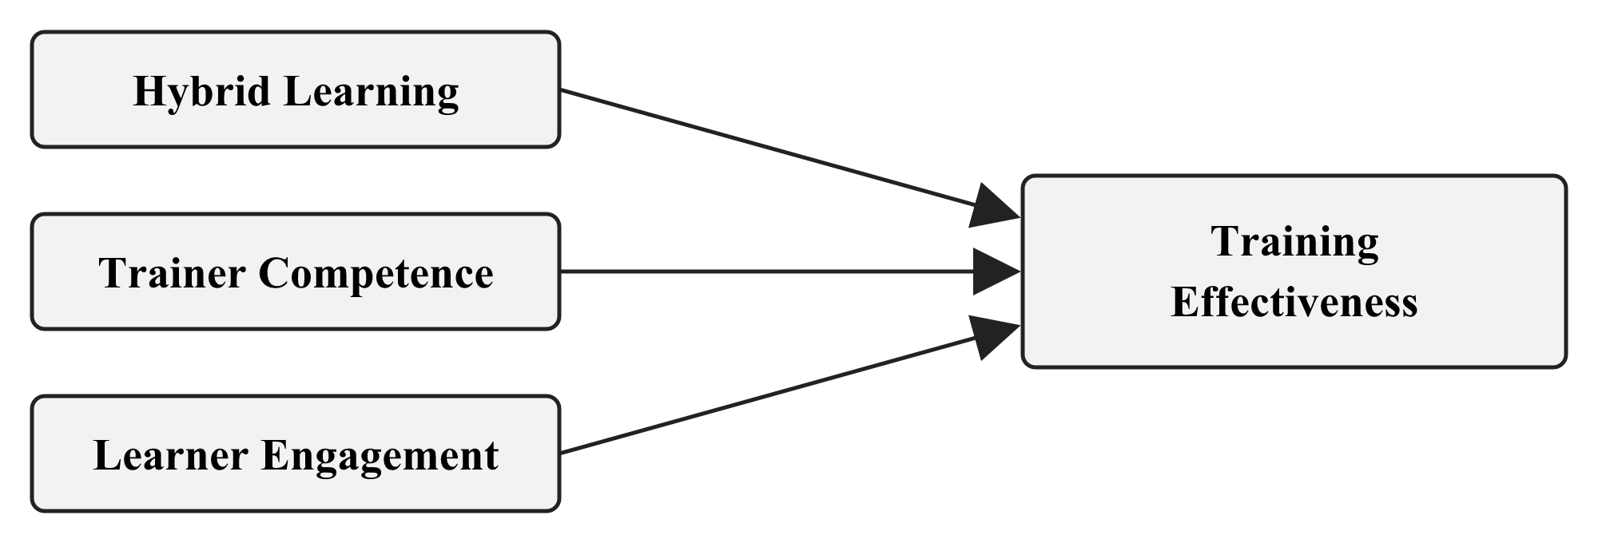
Within the framework, Hybrid Learning, Trainer Competence, and Learner Engagement all act as separate predictors of perceived Training Effectiveness. It is not necessary for a well-organised programme and a capable trainer to lead to the same degree of engagement among all employees. Factors such as workload, available time, previous experience, digital confidence, motivation, and the conditions at the branch may also play a role. The questionnaire documents the way in which employees experienced these various aspects of the programme; the associations thus obtained are then interpreted within the constraints of a single self-report survey.
Each of the three base papers looks at a different aspect of the question. Sosnova et al. (2025) examine hybrid education and learning effectiveness among students, offering a conceptual basis for the topic. Kim (2022) investigates automotive sales training and highlights delivery design, instructor involvement, and practice in a corporate setting. Bahl, Kiran and Sharma (2024) evaluate training among 402 Indian bank employees using Kirkpatrick’s Reaction, Learning, Behaviour, and Results framework. The four-construct Union Bank model draws on these complementary perspectives; it does not come from a single paper.
For HR and learning-and-development staff, the design of a programme matters because employees must fit training around their work. Disconnected activities can feel like an extra obligation. A trainer who explains why an activity matters and responds to questions can make participation easier. By examining access, integration, trainer support, and engagement, the research identifies aspects of training that the Bank can review while maintaining regular service.

1.2 Key Concepts and Definitions

Hybrid Learning
Hybrid Learning involves combining digital activities with face-to-face ones as part of a single planned programme. For the digital element a bank could make use of an LMS module, a video, a virtual session, an online assessment or downloadable reference material. The in-person component could be provided by classroom discussion, a demonstration, role play, a group exercise or supervised practice. Each of these methods has a specific purpose within the same learning sequence.
The employees assessed whether the two methods felt connected, whether they were able to access the platform and the materials, and whether the digital materials remained available for revision. This evaluation relates to their experience of the programme in question and is not a technical assessment of Union Vidya nor a comparison of the programmes delivered via a single mode.

Trainer Competence
The level of a trainer's competence depends on how effectively they support the learning process. It is important that they have subject knowledge and provide clear explanations, as well as being able to link the work carried out online with the live session, to use appropriate tools, encourage participation and offer useful feedback. In a hybrid programme, employees might need the trainer to demonstrate how an online task relates to the subsequent discussion or to a procedure in their own role.
An accessible platform cannot replace an explanation from a trainer. Equally, a capable trainer may be constrained when employees cannot obtain the learning material. Measuring these experiences separately permits a comparison of their associations with Training Effectiveness.

Learner Engagement
Learner Engagement refers to the various aspects of what an employee contributes to the programme in question, such as their attention, effort, participation, interest, and readiness to ask questions. Simply being present or having completed the programme online does not demonstrate this level of involvement. A person may be there without paying close attention to the material; it is shown by their attempt to understand it and by their participation in the learning activities.
The questions which relate to engagement are concerned with behaviour in a single training programme and do not evaluate general work engagement, organisational commitment, motivation, or metacognitive skill since these are additional constructs.

Training Effectiveness
Training Effectiveness refers to the employee's view of the contribution of the programme to their current work, and the questions address understanding, relevance, confidence, and the extent to which the employee feels they can apply what they have learned to everyday tasks and related problems.
The literature on training evaluations and transfer backs this definition, going beyond simply asking whether the employees had liked the session. Nevertheless, the evidence obtained is based on people's own reports: in this case, no objective improvement is measured in individual performance, customer service, productivity, reputation, or financial results.

Learning Management System
A Learning Management System (LMS) enables an organisation to deliver and manage learning by means of various digital resources, including modules, readings, videos, quizzes, virtual sessions, and learning records. Within its wider system of e-learning, virtual training, staggered programmes, and role-based learning, Union Bank has chosen Union Vidya as its LMS (Union Bank of India, 2024, 2025).
Union Vidya is given as an example when the questionnaire is asking about the platform used in the programme that the respondent has chosen, since there can be differences between programmes and platform features and it is not assessed as a separate item.

1.3 Need, Scope and Significance of the Study

Need for the Study
The main issue is the connection between employees' experience of Hybrid Learning, Trainer Competence, and Learner Engagement and their perception of Training Effectiveness. Bank employees acquire their knowledge by handling customers, carrying out various procedures, and managing their daily duties. When the activities are hard to access or poorly linked, training tends to increase the pressure on them rather than assist them in applying their new knowledge.
Research into blended learning provides some valuable insights into the design of programmes, even though a great deal of it focuses on students. In the case of a bank employee, customer service and compliance duties go on during the training period. Corporate studies include evidence from the work environment, but there is still a lack of research looking at the four constructs together among the employees of an Indian public-sector bank.
Union Bank has recorded its digital resources and the training facilities which are led by trainers. These records show what the setup is rather than the quality of the employee's experience within a particular programme. It is the survey that looks at this more specific question.

Scope of the Study
The respondents who were eligible had to be employees associated with Union Bank's Regional Office in Chennai South and must have taken part in a programme that included both digital and face-to-face elements over the past 12 months; each person was to discuss one programme that had recently taken place. Those who had taken part in only one of the two modes of delivery were unable to judge how the two were linked and so were not eligible.
The areas that are measured include Hybrid Learning, Trainer Competence, Learner Engagement, and Training Effectiveness; other factors which might be relevant, such as knowledge retention, job performance, supervisor support, digital literacy, and Union Vidya's technical performance, are not covered by this model. Using a more focused tool makes it possible to keep the analysis manageable for the selected sample.
Responses were collected once using a structured five-point agreement questionnaire. Descriptive and correlational analyses describe this group of respondents and the relationships among their ratings. The design cannot establish later changes in work behaviour or Bank performance caused by training.

Significance of the Study
The results for Union Bank show how employees have responded to the relationship between different learning methods, the level of support provided by trainers, and the extent of their participation. Those aspects which have received lower ratings can help staff identify areas that should be looked at, for example regarding the timing of the modules, access to the materials, the guidance given, the feedback offered, or the opportunities for taking part.
Trainers and members of the learning-and-development team can make use of these responses in order to go beyond simply delivering the content. Employees should also understand the reason why a digital module comes before a session, how a new procedure relates to their particular role, and where they can go to ask questions afterwards. These practical links influence whether the training seems manageable when combined with their normal duties.
The academic contribution consists of a detailed account based on experience in the public-sector banking environment. The questionnaire was developed by drawing upon conceptual, corporate, and Indian banking literature; it was examined by the supervisor, tried out, and evaluated for internal consistency in the final sample.

1.4 Statement of the Problem
The learning system at Union Bank makes use of digital materials as well as trainer-led activities, which provides the possibility of hybrid training. However, the fact that such resources are available does not indicate much about an individual employee's actual experience. What remains to be determined is whether the activities are coherent, if the trainers offer adequate guidance, whether the employees take part, and whether they can apply what they have learned to their present jobs.
The evidence available from higher education and corporate training provides some context for these questions, but it does not look at the four constructs together in the specific case of Union Bank. Specifically, the published material on Union Vidya fails to explain how employees link its digital resources with trainer-led learning.
The research tests whether ratings of Hybrid Learning, Trainer Competence, and Learner Engagement jointly relate to perceived Training Effectiveness.

1.5 Research Questions
1. What are respondents’ perceptions of Hybrid Learning, Trainer Competence, Learner Engagement, and Training Effectiveness?
2. What associations are reported among the four study constructs?
3. To what extent do Hybrid Learning, Trainer Competence, and Learner Engagement jointly predict Training Effectiveness?

1.6 Industry and Company Context

Banking Industry Context
The banking industry involves regulation, digital systems, a range of products, and customer service. Each day, staff are required to keep up to date with regard to procedures and risk controls as they are serving customers. In a public-sector bank with employees spread across various departments and locations, general material has to be available without compromising the chances for questions, practice, guidance, and subsequent revision.
Since different training needs exist, different types of activities are required. For example, a brief policy update would be appropriate for a digital module followed by a knowledge check; a new procedure might need to be demonstrated and then practised; and a situation involving customers could be more easily dealt with using role play. Digital material can stay available afterwards. The mode chosen should be one that corresponds to the task the employees need to learn.

Union Bank of India Context
Union Bank was set up in Mumbai on 11 November 1919 and was nationalised in 1969. On 1 April 2020, Andhra Bank and Corporation Bank joined it by way of amalgamation (Union Bank of India, n.d.-a). The bank's public profile stated that it had more than 8,700 domestic branches and 73,900 employees in June 2026. Since its workforce is distributed over such a large number of locations, it becomes a practical issue to have access to up-to-date materials and to receive trainer support.

Union Bank Training Architecture
Union Bank promotes learning by providing both physical training facilities and digital courses. According to its 2024–25 annual report there is a Master Policy on Learning and Development which includes e-learning, virtual and staggered programmes, role-based training, mandatory e-learning for officers, and a Training Management System within Union Vidya (Union Bank of India, 2025). The previous annual report designates Union Vidya as the Bank's LMS and lists its digital resources and virtual workshops together with classroom and locational programmes (Union Bank of India, 2024).
In 2022, nine specialised Union Learning Academies were set up. According to the Bank's public list, there is also a Staff Training College in Bengaluru and seven further Staff Training Centres (Union Bank of India, 2022; Union Bank of India, n.d.-b). Along with the digital facilities, these institutions make up its learning infrastructure, though their presence does not prove that anyone attended a centre or that each programme combined both modes.
The circular, which dates from 9 September 2026, cites an example of a link between the different modes. Classroom sessions that have been selected at the Union Learning Academies and the Zonal Learning Centres can be watched via Microsoft Teams, with the schedules and recordings being made available through Union Vidya, and virtual participants being able to pose questions in the chat for the programme coordinator to raise at appropriate intervals (Union Bank of India, 2026). This arrangement enables access to certain trainer-led sessions; however, the circular contains no information regarding the effects on employees within the Bank.
The survey therefore focuses on what eligible employees connected with Regional Office Chennai South reported about one recent hybrid programme. Its findings concern those respondents rather than the Bank as a whole.

1.7 Chapterisation
The banking context the four constructs the research problem and the questions that guide the study are all outlined in Chapter 1.
The chapter looks at the relevant literature and outlines the roles of the three fundamental papers; it then presents the framework together with the gap that is addressed in the case of Union Bank.
Chapter 3 sets out the objective, the hypothesis, the method of sampling and the procedure for data collection, the questionnaire, the analysis, and the ethical safeguards.
Chapter 4 sets out and explains the results. Chapter 5 summarizes the findings, the limitations, the recommendations, and reaches a conclusion.

CHAPTER - 2
REVIEW OF LITERATURE

CHAPTER 2 — REVIEW OF LITERATURE

2.1 Review of Relevant Literature

Hybrid Learning as an Integrated Training Design
Hybrid learning in the workplace involves more than simply allocating a certain number of hours for an online module and a classroom session; the various activities have to be arranged in a sequence that employees can follow and apply to their own work, and a digital task should have a clear reason for coming before or after a trainer-led activity.
Digital delivery can distribute basic information, short assessments, and material for later reference across locations. In-person time can be used for questions, demonstration, practice, and feedback. Employees are more likely to see a programme as one course of learning when they understand why those activities are connected.
Garrison and Kanuka (2004) place integration at the centre of blended learning. Graham (2006) discusses the combination of delivery modes, teaching methods, and learning approaches. Although both accounts come mainly from education, they offer a relevant design test for employee training: the activities should support one another, not repeat or conflict with each other.
Two educational reviews contribute to the wider discussion about learning. Vo, Zhu and Diep (2017) pooled 51 effect sizes from courses in higher education and found a small average benefit of blended learning compared to traditional classroom teaching (g = 0.385). Yu, Yu, Li and Wang (2025) examined 133 studies involving 18,464 students and identified an upper-medium effect on learning performance (g = 0.651). These figures refer to students. Since bank employees frequently have to learn while dealing with customer service, meeting deadlines, and adapting to new procedures, the estimates only serve as background information and not as a prediction for Union Bank.
Kumar and Pande (2017) examine technology-mediated learning among working professionals. They identify institutional, facilitator, learner, and pedagogical conditions within a blended-learning ecosystem. Their account is useful here because access to a platform alone cannot explain whether employees find the content relevant, receive guidance, or carry learning into work.
The relevance of Mulaudzi's (2021) Master's dissertation to employees who have to undergo training around their regular work lies in its examination of issues such as time, access, flexibility, teaching materials and practical obstacles. These themes have therefore been reflected in the way the questions in the present questionnaire are phrased with regard to access and connected learning, even though the questionnaire instrument from the dissertation was not used directly as a ready-made corporate scale.
The Questionnaire on the Perceptions of the Blended Learning Environment developed by Han and Ellis (2020) inquires into how learners perceive the relationship between different modes and the role of online learning; however, its language, which is geared towards higher education, is not appropriate for use directly with bank employees. The fundamental themes involved—namely, connection, access, availability of materials, and revision—help to explain the content of the Hybrid Learning items.
Sosnova, Hlianenko, Sosnova, Tsyna and Tsyna (2025) provide the conceptual base paper. Their experiment with 64 higher-education students combined online platforms with practice-oriented, problem-based, interactive, and project activities. Learning outcomes were stronger for the hybrid group than for the comparison group. The population and outcome measures differ from those in this thesis, and the paper offers no Union Bank questionnaire. It is used for the narrower proposition that hybrid design and learning effectiveness can be studied together.

Hybrid Training and Effectiveness in Corporate Settings
The corporate training evidence is provided by Kim (2022). In South Korea automotive sales training the method of delivery shifted from traditional to fully digital and then to a hybrid approach. The analysis includes 583 training cases from 2019 to 2020: 325 traditional, 140 fully digital and 118 hybrid. Different from the more self-directed fully digital format, the hybrid format involved both online and offline activities.
The effectiveness of the training was assessed using Kim’s Content, Instructional Design, Programmed Learning, and Recommendation (CIP-R) framework, a framework that includes content, design, personalised learning, perceived competence, and recommendation. Effectiveness was found to decrease when the method of delivery changed from traditional to fully digital training and increased afterwards when a hybrid approach was introduced. Factors linked to the reported outcome included instructor engagement, duration, personalised learning, confidence and competence, and job-related skill level.
The order in which Kim's group ranked the different types of training was such that traditional training came top, hybrid training followed it, and fully digital training was at the bottom. There was no statistically significant difference between the hybrid and fully digital methods of delivery. Kim is therefore unable to make a general assertion that hybrid training is better. The paper is more helpful in illustrating the reasons why the design of the delivery, the role of the instructor, and practice should all be taken into account when assessing a corporate programme.
The current decisions regarding measurement are based on Kim's findings; training effectiveness includes more than just a positive immediate reaction; hybrid learning relates to the quality of the link between the different methods; and trainer competence stays distinct since having access to digital materials does not take the place of guidance and feedback.
The term “hybrid” does not indicate whether an employee could access the materials, prepare in advance, take part, or practise. This matters when staff from different branches attend training while normal work continues. The Union Bank questionnaire therefore asks about activities within one programme and the support available, rather than asking employees to compare formats they may never have experienced.
Instead of comparing corporate delivery methods, this thesis seeks to find out from individual bank employees whether one of the programmes had helped them to understand and apply work-related learning. The designs are not going to yield exactly the same results, but the comparison at the corporate level does make the question at the employee level worth investigating.
Uddin, Ahamed, Jakowan, Islam and Nahar (2026) studied 150 employees with blended-learning experience. They examined soft-skill development and knowledge acquisition in relation to employee performance. Both learning-related variables had positive relationships with blended learning, while the direct relationship with performance was not significant after those pathways were considered. Their result cautions against inferring a work outcome from delivery format alone.
Uddin and others have provided relevant literature relating to the workplace. In order to test the specific pathways concerning soft skills, knowledge acquisition, and performance, it would be necessary to use measures that are not included in this four-factor survey.

Trainer Competence in Hybrid Training
When training moves between a platform and an in-person session, the trainer helps employees make sense of the sequence. Clear subject explanations, links between activities, suitable digital-tool use, questions, and feedback can all matter. Without such support, completion of an online task may remain disconnected from the employee’s responsibilities.
The quality of the technical platform and the level of competence of the trainer are two distinct issues. It is possible for the material to be available on line without there being an explanation of its purpose; similarly, an experienced trainer may have difficulty when employees are unable to access that material. That is why the questionnaire includes separate sections relating to programme design and trainer support.
No selected base paper tests Trainer Competence and Learner Engagement together in this exact workplace model. Kim (2022) discusses instructors, participation, practice, and design in corporate training. Mulaudzi (2021) addresses facilitation and practical access barriers at work. In a university setting, Ansari et al. (2023) associate blended-learning training with lecturer and student competence and satisfaction. That population differs from bank employees, but the study adds support for examining facilitation rather than treating technology availability as enough.
These sources help distinguish the trainer’s contribution from the employee’s response. The Trainer Competence items cover explanation, digital facilitation, connections across modes, participation support, and feedback. The Learner Engagement items concern attention, effort, involvement, questions, and interest. A favourable trainer rating is not automatically an account of active learner participation.

Learner Engagement
Engagement refers to active involvement, such as showing attention, putting in effort, taking part, displaying interest, and asking for clarification. Since a login or attendance record does not indicate whether a person made an attempt to understand a changing procedure, completion is only a partial description of the learning process.
Schaufeli, Bakker and Salanova (2006) define work engagement as comprising vigour, dedication and absorption. Their scale does not serve as a measure of one's participation in a specific training programme. The items used in the present study are based only on the general concept of active effort, namely that respondents indicate the degree of their attention, participation, involvement, questioning and interest during the programme in question.
Learner Engagement has to be considered an independent variable since neither the design of the programme nor the trainer's skill is enough to determine an employee's level of attention or involvement. Other factors such as time pressure, previous experience, digital confidence, motivation, and the conditions of the branch can also influence the response. The model therefore looks at the relationship between engagement and Training Effectiveness rather than assuming that engagement is fixed in a particular sequence between the other variables and the outcome.

Training Effectiveness
Kirkpatrick's framework distinguishes between reaction, learning, behaviour and results. This distinction means that a positive reaction to a session cannot be taken as equivalent to all the outcomes of the training. It is possible for an employee to enjoy a session without understanding it, or to understand it without later having the opportunity to apply what they have learned.
Bahl, Kiran and Sharma (2024) provide the Indian banking base paper. Their open-access assessment covers 402 managerial and non-managerial employees in public, private, and foreign banks and applies Kirkpatrick’s four levels. It shows why training evaluation matters in banking. It does not examine hybrid delivery, trainer competence, learner engagement, or Union Vidya, so it cannot supply the current model on its own.
Holton (1996) argues that evaluation levels do not by themselves explain transfer into practice. Baldwin and Ford (1988) describe transfer through the generalisation and maintenance of learning at work. Blume et al. (2010) find links between transfer and characteristics of the learner, training design, and work environment. These sources caution that later application depends on more than the training event.
The criterion used in this case is more limited in that employees are asked to assess the extent to which the training covers understanding, relevance, capability, its applicability to tasks, its value in helping with related problems, and the confidence it has given them in carrying out their present responsibilities; they are not required to judge productivity, customer satisfaction, the bank's reputation, or its financial performance, since that would demand further data.
Aziz’s (2015) General Training Effectiveness Scale was developed for Malaysian workplace learning. Its distinction between individual learning and organisation-level outcomes informs the present questionnaire’s employee-level focus. Union Bank wording was then reviewed for content, piloted, and assessed through reliability analysis.
Bahl, Kiran and Sharma (2024) evaluate a broader chain that includes results. This survey has no independent record of branch productivity, customer outcomes, or behaviour observed over time. It can instead ask whether employees understood the content, recognised its relevance, and felt able to use it. That is a perceived employee-level outcome, not a full Kirkpatrick evaluation.
Aziz (2015) also helps keep individual learning distinct from what an organisation achieves. A respondent cannot reasonably judge a Bank-wide result from one recent programme. Job Performance was left outside the model for a related reason: actual performance would need a suitable measure and evidence beyond the same employee’s account of training.

Workplace Implementation Conditions
While an LMS can store the content, it is up to people to decide what should be read before a session, what should be discussed, and when feedback is required. Likewise, a classroom discussion might not provide employees with material that they can go back and review later. This link between the different activities is at the heart of the Hybrid Learning measure.
Mubayrik’s (2018) review of workplace blended learning identifies flexible access, authentic activities, collaboration, satisfaction, and support with technology as recurring themes. The studies vary in population, design, and measurement. Their variety is a reason to examine the task, trainer, technology, and opportunity to participate in a particular setting instead of assuming one delivery format works equally well everywhere.
Sequence matters when employees must make time for training alongside work. A digital activity might introduce a policy or demonstration before a live session devoted to cases and practice. Alternatively, a trainer might introduce a difficult topic first and leave digital material for revision. The questionnaire asks whether the selected programme’s activities felt connected and accessible; it does not rank these possible sequences.
A possible approach would be digital preparation, followed by practice led by a trainer, then applying it in the workplace and finally carrying out digital feedback. This example illustrates what a connected programme could be like. It is not another model that was tested in the survey.

Use of the Literature in Practical Recommendations
The recommendations should start with the actual ratings given by the respondents and then refer to the relevant literature to interpret these ratings; if the scores for access or materials are low this would indicate a problem with the timing or availability of resources; if the ratings for explanation or feedback are low it would point to the need for reviewing the trainer's preparation; and if participation or seeking clarification is limited the focus should be on the questions, practice, and follow-up.
The employee ratings point out the strengths or difficulties in the chosen programme, and the studies that have been reviewed help to explain why these areas might be important.

Summary of the Empirical Review
The sources perform complementary roles. Sosnova et al. (2025) connect hybrid methods and learning effectiveness in education; Kim (2022) studies corporate training design, instructors, practice, and outcomes; and Bahl, Kiran and Sharma (2024) evaluate training among Indian bank employees. Han and Ellis (2020), Mulaudzi (2021), and Aziz (2015) inform the themes and workplace wording of the questionnaire.
No single source provides the whole model or an instrument ready for Union Bank; it is Appendix B that shows how the scored items draw on these separate strands of literature.

Comparison of the Three Base Papers
The studies refer to three different settings rather than using the same model. Sosnova et al. (2025) focus on students; Kim (2022) looks at trainees in the automotive sales field; and Bahl, Kiran and Sharma (2024) look at Indian bank employees without including a hybrid-delivery measure. The fact that these studies differ is what makes the Union Bank question relevant, but none of them provides a result that can be directly replicated in Chennai.
Their methods also set limits on comparison. Sosnova and Kim compare arrangements or outcomes across delivery conditions, while Bahl and colleagues use a multi-level evaluation framework. The current one-time questionnaire describes four ratings and tests a single regression. It cannot show that changing Union Bank’s delivery mode would reproduce an earlier result or yield organisation-level outcomes.
All of the points made by Kim regarding instructors and participation, Mulaudzi's (2021) account of facilitation and time in the workplace, and Schaufeli, Bakker and Salanova's (2006) idea of active effort help in distinguishing between trainer support and learner behaviour. Since the last of these refers to general work engagement, it is included here as background rather than as a measure for training. Even if a bank employee appreciates the trainer's explanation, he or she may still not have much time to get prepared or to ask questions. The two aspects are therefore assessed separately.
The other measurement sources have a different aim: Han and Ellis (2020) address questions concerning the relationship between modes, Mulaudzi (2021) provides information on workplace access conditions, and Aziz (2015) offers support for an employee-level outcome. Appendix B shows how these themes were adapted to apply to one Union Bank programme. A student scale or a transport-sector instrument does not automatically become a validated Bank measure just because its wording has been changed.
The literature leads to one focused test: among employees exposed to both modes, do more positive ratings of integration, trainer competence, and engagement accompany higher perceived Training Effectiveness? The answer can direct attention to areas for review, while the one-time design leaves time order and causation unresolved.

Literature Summary
Table 2.1: Literature supporting the present study
Study | Context and contribution | Use in the present study
Sosnova et al. (2025) | Hybrid education experiment with higher-education students; examines learning effectiveness. | Conceptual anchor for examining Hybrid Learning and learning effectiveness.
Kim (2022) | Corporate automotive sales-training study comparing delivery methods. | Corporate evidence on training design, instructor involvement, participation, and Training Effectiveness.
Bahl, Kiran and Sharma (2024) | Open Indian banking study of 402 employees using Kirkpatrick’s framework. | Banking-sector anchor for employee-level Training Effectiveness.
Han and Ellis (2020) | Validated blended-learning-environment instrument in higher education. | Supports the structure of Hybrid Learning items, adapted for the workplace.
Mulaudzi (2021) | Workplace blended-learning study in the transport sector. | Supports workplace wording on access, materials, flexibility, and facilitation.
Aziz (2015) | Workplace training-effectiveness scale development. | Supports employee-level learning, relevance, and application items.

2.2 Theoretical Framework

Blended-Learning Integration
The framework begins with the integration of learning modes described by Garrison and Kanuka (2004) and Graham (2006). Digital work and a live session should form an intelligible sequence. When employees can see the connection, the purpose of each activity is easier to understand.
For an employee, the sequence could involve digital material being used to introduce a topic prior to the session on cases and practice; this material could then be kept available when it is necessary to check a procedure later on. Alternatively, the programme might start with a live explanation and make use of digital resources for follow-up. What is important is that employees recognise the link between the activities and the work need.
The programme design cannot be determined by the platform employed. Simply posting a module does not guarantee that it will prepare staff for discussion; moreover, a well-designed classroom activity can also be difficult to apply later on without a reference resource. That is why the Hybrid Learning entries make reference to both connection and access, and not just to a login or completion record.

Separate Employee-Level Predictors
The second perspective keeps three related experiences distinct. Kim (2022) discusses design, instructors, participation, and practice in corporate training. Ansari et al. (2023) and Mulaudzi (2021) add evidence about facilitation and access across learning modes. Employee engagement may also reflect circumstances beyond either the trainer or programme. This is why all three are measured separately and entered together in the regression.
There is the case of an employee who receives the material, understands the trainer, but is unable to take part due to the demands of their branch work. In another instance, someone may be willing to learn but be unable to locate the digital resource. Combining such situations in a single positive or negative rating would mask the aspect of the experience that requires improvement.
The predictors can still be linked. Although clear instructions can help employees carry out a digital task, related activities may encourage them to take part. The model permits these associations to exist without requiring that one predictor lead to engagement in a particular sequence. It examines how the three ratings relate to Training Effectiveness when they are considered as a group.

Training Evaluation and Transfer
Training evaluation and transfer provide the third perspective. Kirkpatrick (1994) distinguishes immediate reaction from later outcomes. Holton (1996), Baldwin and Ford (1988), and Blume et al. (2010) discuss how the learner, design, and work environment relate to application. The outcome here is the employee’s report of understandable, relevant, useful, and applicable learning, not an organisation-level result.
“Effectiveness” can otherwise mean several different things. Enjoying a trainer’s session is a reaction; understanding a concept is learning; using it in a task is application. A Bank-wide change in service or productivity is broader still. The questionnaire concentrates on understanding, role relevance, and reported use or ability to use the learning.
Training-transfer literature also considers what happens after a session. An employee may understand a procedure yet lack the opportunity, time, or support to use it immediately. Since a single survey cannot follow a skill over several months, it can show only whether respondents perceive a link between training and their present duties (Baldwin and Ford, 1988; Holton, 1996).

Conceptual Framework
The theoretical perspectives support the following framework:
Hybrid Learning, Trainer Competence, and Learner Engagement are included in the model as independent variables. The arrows indicate the SPSS predictor–outcome analysis, without stating any order among the predictors or showing causation.
The questionnaire sections each have a specific purpose: to assess arrangement and access, trainer support, employee participation, or perceived learning and relevance. Separate sections can identify a weaker aspect of the experience even when overall ratings are high. The regression provides the joint test, while item responses point to areas for review.

2.3 Case Study: Union Bank of India
Respondents were employees associated with Union Bank’s Regional Office Chennai South. Their work can require current knowledge of products, procedures, risk controls, digital systems, and customer service. This setting makes continuing training relevant to daily work.
The annual reports refer to both digital and trainer-led training. According to the 2023–24 report, Union Vidya was introduced as the Bank's LMS, along with digital materials, virtual workshops, and classroom and locational training. The 2024–25 report mentions the Master Policy on Learning and Development, e-learning, virtual and staggered programmes, ten mandatory e-learning modules for officers, role-based training, and a Training Management System on Union Vidya (Union Bank of India, 2024, 2025).
In 2022 Union Bank opened nine specialised Union Learning Academies. The list of its public training centres includes the Bengaluru Staff Training College and seven other Staff Training Centres (Union Bank of India, 2022; Union Bank of India, n.d.-b). Although these records show that the bank has physical training facilities they do not provide details about each employee's programme.
A circular issued internally on 9 September 2026 states that certain classroom sessions at the Union Learning Academies and the Zonal Learning Centres are being live-streamed via Microsoft Teams. The schedules and recordings are made available on Union Vidya and enable participants taking part virtually to ask questions using the chat function (Union Bank of India, 2026). This serves as an instance of trainer-led sessions being extended by means of digital access.
While these resources make Union Bank a suitable setting for the study of hybrid learning, the infrastructure by itself is not enough to show us how the programme was experienced by the participants. That is why the survey inquiries eligible employees about one recent programme which involved both modes, including the access and support they had.
The respondents evaluate just their own programme and not the whole training system; they are not required to compare different programmes or to provide information about customers, confidential records, or Bank-wide performance data.

2.4 Gaps in the Study
The workplace-context gap arises because much blended-learning evidence and measurement work comes from higher education. Employees train alongside schedules, customer needs, and work pressure. Corporate studies exist, but provide less direct evidence about these experiences than the student literature.
The gap in the banking sector still exists even though Bahl, Kiran and Sharma (2024) examined the effectiveness of training among employees of Indian banks. The model they developed does not cover Hybrid Learning, Trainer Competence, Learner Engagement, or Union Vidya. While Union Bank provides information about its learning facilities, it does not explain how employees experienced the combination of different methods in a single programme.
The gap known as the predictor-combination gap lies in the fact that the three individual papers do not look at the three independent constructs together. Sosnova looks at hybrid methods in the field of education, Kim compares different corporate delivery arrangements, and Bahl, Kiran and Sharma assess training in the banking sector. They do not together test the three independent constructs against employee-level Training Effectiveness in a public-sector bank.
The gap in measurement is a result of the settings of the available scales: although one of the blended-learning tools was designed for students, the scale relating to workplace effectiveness covers organisation-level outcomes as well. Neither of these can be used in the short bank survey without modification. The four sections of the questionnaire had been informed by the relevant literature, were reviewed by the guide, and were piloted online with 20 eligible employees on 15–16 September 2026. While SPSS gives a report on the overall consistency of the 26 items, it does not provide a separate reliability estimate for each construct.
The study relates to the area where these different fields of research come together: namely, employees' experiences of hybrid delivery, trainer support, participation, and the perception of effectiveness in a public-sector bank that uses Union Vidya as part of its learning system.

CHAPTER - 3
RESEARCH METHODOLOGY

CHAPTER 3 — RESEARCH METHODOLOGY

3.1 Objectives of the Study
This study investigates the way in which eligible Union Bank employees experienced a hybrid training programme and the relationship between their ratings and their perception of training effectiveness. In this programme they could make use of digital materials and attend sessions led by trainers while at the same time carrying out their normal bank duties. The criterion is their description of the programme, not just the fact that an LMS was used.
The primary objective is:
The aim is to find out whether Hybrid Learning, Trainer Competence, and Learner Engagement together are associated with Training Effectiveness among eligible Union Bank respondents.
The specific objectives are:
1. To describe respondents’ perceptions of Hybrid Learning, Trainer Competence, Learner Engagement, and Training Effectiveness.
2. To examine the associations among the four study constructs.
3. To determine the joint contribution of Hybrid Learning, Trainer Competence, and Learner Engagement in predicting Training Effectiveness.
The aims here are concerned with associations and statistical prediction within the sample in question, without asserting any causal relationship.

3.2 Hypothesis of the Study
A single overall regression hypothesis is examined at the 5 per cent level of significance.
Table 3.1: Regression hypothesis
Null hypothesis (H₀) | Alternative hypothesis (H₁)
Hybrid Learning, Trainer Competence, and Learner Engagement do not jointly predict Training Effectiveness among eligible respondents of Union Bank of India. | Hybrid Learning, Trainer Competence, and Learner Engagement jointly predict Training Effectiveness among eligible respondents of Union Bank of India.

The hypothesis relates to the model as a whole, and the coefficients are given separately in order to show the adjusted association of each predictor after allowing for overlap with the others.

3.3 Definition of Variables
The questionnaire yields scores for four constructs.
Hybrid Learning refers to the way in which digital and face-to-face activities are combined within a programme, and questions 5 to 11 deal with its design, platform access, the materials available and later revision.
Trainer Competence includes knowledge of the subject, clear explanation, connections between different modes, the appropriate use of digital tools, encouragement, and feedback. It is assessed through Questions 12 to 17.
Learner Engagement means the level of attention, effort, participation, questioning, and interest shown by the respondent while undergoing the programme in question, and it is measured by Questions 18 to 23. Engagement is still considered an independent variable since factors such as workload, available time, prior experience, motivation, digital confidence and local conditions can influence participation even beyond what is provided by the programme design or trainer support.
Training Effectiveness includes aspects such as perceived understanding, the relevance of the role, capability, application to other tasks, and confidence. Questions 24 through 30 deal with these employee-level outcomes.
Table 3.2: Construct operationalisation and item allocation
Construct | Questions | Number of items | Role in the regression model
Hybrid Learning | 5–11 | 7 | Independent variable
Trainer Competence | 12–17 | 6 | Independent variable
Learner Engagement | 18–23 | 6 | Independent variable
Training Effectiveness | 24–30 | 7 | Dependent variable
Total Likert-scale items | 5–30 | 26 | —

The questionnaire consists of 30 numbered questions: four relating to eligibility and profile and then 26 items which require a five-point agreement. Knowledge retention, job performance, organisation-level results, employee agility, supervisor support, and Union Vidya's technical performance are not further variables that are measured.

3.4 Research Design
The design is, in a statistical context, quantitative, descriptive, correlational and predictive; it makes use of structured ratings to describe the response pattern, shows the direction and strength of the associations between pairs of variables, and employs SPSS regression to examine the three independent variables in relation to Training Effectiveness.
Each respondent filled in the survey once regarding a hybrid course which they had taken in the previous 12 months. When referring to a single programme there is no need to combine the memories of a number of different courses. The individual response record is the unit on which analysis is carried out.
The model is:
The predictors may be related, but the model does not assume that programme design or trainer skill determines engagement. Other employee and work conditions outside the questionnaire may matter too.

3.5 Population, Sample and Sampling Method
The group under consideration consisted of the employees associated with Union Bank's Regional Office in Chennai South who had taken part in a programme that included both digital and face-to-face learning during the previous 12 months.
The employees who had the relevant experience and were selected with a view to ensuring that they could answer the questions were those who had taken part in both methods within the specified period, since the survey involves questions regarding the connection between them.
The collection was restricted to those offices and branches that could be accessed during the internship. The question concerning eligibility was used to identify individuals with the relevant training experience. Since the respondents were not selected at random from a complete list of all employees of the Bank, the resulting percentages and associations cannot be generalised statistically to the entire workforce of Union Bank.
The initial target was about 80 eligible respondents. Collection yielded 132 submissions—70 on paper and 62 through Google Forms. After screening, 103 records had complete profiles. SPSS used 102 valid cases in the multiple regression because one record lacked a Trainer Competence mean in its analysis file.
No employee name or number was requested. Each valid form was treated as one response record; similar answer patterns alone were not evidence that the same person responded twice.
It is not possible to determine the number of employees who were contacted or who were sent the link, therefore a formal response rate cannot be obtained. Instead, Table 3.3 takes into account the number of forms received and kept.

3.6 Data Collection Procedure and Screening
The researcher employed printed forms together with a Google Forms link. The fieldwork records name the Regional Office Chennai South and 27 branches in Chennai: Triplicane 1, Triplicane 2, Triplicane 3, Alandur, Teynampet, Mowbrays Road, Chamiers Road, Mylapore 1, Mylapore 2, Mylapore 3, Adyar, Madhya Kailash, Besant Nagar 1, Besant Nagar 2, Indiranagar, Shastri Nagar, T. Nagar 1, T. Nagar 2, T. Nagar 3, West Mambalam, Nungambakkam, Koyambedu, Virugambakkam, Saligramam, Ashok Nagar 1, Ashok Nagar 2, and Ashok Nagar 3. The Retail Loans and Currency Chest at the Regional Office were also designated as collection points. With the online option, staff were able to respond at a later time when their branch duties made it impossible for them to complete the paper form immediately.
Main-study collection began at the Regional Office on 15 September 2026 alongside the separate online pilot. The fieldwork record places branch visits from 16 to 28 September 2026. All pilot submissions had been received by 16 September and were kept outside the main-study count.
The researcher obtained verbal permission from the Regional Office HR Manager. The manager contacted branch staff to support collection while customer service continued. The paper and online forms contained the same 30 questions and response scale. Offering both modes made participation easier, although possible differences between paper and online responses were not separately tested.
Source: Researcher’s internship fieldwork record.
Table 3.3: Response disposition and SPSS analysis cases
Disposition | Digital | Manual | Total
Responses received | 62 | 70 | 132
Q1 = No | 13 | 3 | 16
Q1 blank or unreadable | 0 | 11 | 11
Required profile field blank | 0 | 2 | 2
Profile-complete records before SPSS | 49 | 54 | 103
SPSS listwise exclusion for missing construct mean | — | — | 1
Valid SPSS analysis cases | — | — | 102

Question 1 screened for attendance at a programme combining the two modes within the stated period. Sixteen respondents answered “No”; eligibility was unconfirmed in another eleven records. Two otherwise eligible paper forms lacked a required profile answer. After excluding those 29 forms, 103 profile-complete records remained. SPSS then excluded one case from analyses requiring all four construct means because its Trainer Competence mean was missing in that file. The main regression therefore has 102 cases. The saved viewer output does not identify the case by response ID, which prevents an exact person-by-person reconciliation with the reconstructed supplementary subset.

3.7 Research Instrument and Scoring
Appendix A is the 30-question self-administered instrument, with questions 1 to 4 being used to establish eligibility and to obtain a profile and questions 5 through 30 employing a five-point scale ranging from Strongly Disagree to Strongly Agree; the people surveyed referred to one hybrid programme from the previous 12 months.
The themes for the item are taken from the base papers and the supporting measurement literature, with the adaptations being set out in Appendix B; Union Vidya is designated as the Bank's LMS and is given as an example of a platform which a respondent might have used.
The programme is divided into four sections, each dealing with a different aspect of it. Questions 5 to 11 relate to the delivery and the availability of the material; questions 12 to 17 are about the support provided by the trainer; questions 18 to 23 refer to the employee's own level of involvement; and questions 24 to 30 deal with learning and the usefulness of the material at work. Having these sections separately gives more information than a general evaluation of the programme as a whole.
The answers to questions 5 through 30 are coded on a scale from 1 (Strongly Disagree) to 5 (Strongly Agree); in SPSS the four construct means are designated by the names HLTMEAN, TCTMEAN, LETMEAN, and TETMEAN.
The score for each construct is the arithmetic average of the items assigned to it and stays on the 1 to 5 scale, with higher scores showing more favourable evaluations. Since all the items have the same direction of scoring, there is no need for any to be reverse coded. The use of means enables comparisons to be made between blocks containing six or seven items and serves to summarise the respondents' answers, not their actual job performance or the Bank's overall results.

3.8 Research Questions
1. What are respondents’ perceptions of Hybrid Learning, Trainer Competence, Learner Engagement, and Training Effectiveness?
2. What associations are reported among the four study constructs?
3. To what extent do Hybrid Learning, Trainer Competence, and Learner Engagement jointly predict Training Effectiveness?

3.9 Data Analysis Techniques
The relationship tests and construct summaries were provided by SPSS Statistics 23, and its primary regression analysis was based on 102 valid cases.
Table 3.4: SPSS-based analysis plan
Analysis | SPSS procedure used | Role in the study
Item description | Descriptives with mean, standard deviation, skewness, and kurtosis for 26 items | Chapter 4 presents the seven Hybrid Learning item means used to discuss the lowest-rated aspect of that construct.
Construct exploration | Explore procedure with histograms, Q–Q plots, boxplots, and normality tests | Examines the construct-mean distributions.
Overall questionnaire consistency | One 26-item Cronbach’s alpha analysis | Reports overall internal consistency of the item set.
Exploratory structure check | Principal Component Analysis with varimax rotation | Retained as an exploratory diagnostic; it does not redefine the four theory-based constructs.
Association | Pearson correlation | Describes pairwise associations among the four construct means.
Main hypothesis test | Multiple regression | Tests the combined relationship of Hybrid Learning, Trainer Competence, and Learner Engagement with Training Effectiveness.
Respondent profile | Excel frequency and percentage summary | Describes age group, length of service, and job level for the selected 102 profile-complete records.
Supplementary comparisons | One-sample and paired t-tests, Welch’s independent-samples t-test, and one-way ANOVA | Provides descriptive comparisons for the 102-case scored dataset; these are exploratory and are not the main hypothesis test.
Crosstab suitability check | Pearson chi-square on construct-mean categories | Checks whether those tables have adequate expected cell counts before any inferential interpretation.

The multiple-regression model is:
Training Effectiveness = b₀ + b₁(Hybrid Learning) + b₂(Trainer Competence) + b₃(Learner Engagement) + e
Training Effectiveness is the dependent variable and the other three constructs act as predictors together. The F-test as a whole examines their combined association, while the coefficients in the table indicate what is left for each predictor after the effects of the others have been taken into account.
The pairwise relationships which give context to the joint model are shown by the Pearson correlations. However, neither of the analyses proves a cause-and-effect relationship.
The respondent-profile summary was produced by an Excel workbook, while the supplementary Chapter 4 comparisons were drawn from a subset consisting of 102 records out of the original 103-record scored CSV file. The comparisons are labelled separately since some of the additional tests carried out in the saved SPSS viewer used all 103 cases. However, without the SPSS data file, the exact case-by-case agreement between the different sources cannot be verified. The supplementary comparisons have no role in the decision regarding the main hypothesis.
The same applies to the descriptive results. The construct and regression plots are obtained from SPSS, while the profile frequencies and the supplementary item distributions are derived from the selected scored records. The source of the data and the number of cases are given in the tables. Hence, the SPSS item mean based on 103 cases and the frequency distribution based on 102 cases are not regarded as calculations made on the same group of respondents.

3.10 Questionnaire Review, Reliability and Validity
The guide-approved questionnaire was tested online with 20 eligible employees while main collection was beginning. According to the researcher’s fieldwork record, the pilot ran from 15 to 16 September 2026; the main survey also began on 15 September with the same approved questions. The corrected pilot CSV has no timestamp column, so these dates come from the fieldwork record. Feedback addressed clarity, completion time, Union Vidya wording, relevance, and repetition. No systematic problem required an item to be removed, and scored wording remained unchanged during collection. Pilot records were kept separate from the main analysis.
The pilot also checked completion time: the mean was 15.5 minutes and the median was 15. Sixteen participants thought the length was about right; four found it too long. Comments mentioned possible overlap between Questions 5 and 6 and between Questions 14 and 15. One person found Question 24 difficult when considering more than one programme. The instruction to answer about one selected programme addressed that concern. These comments did not reveal a repeated difficulty across the group, so all scored questions were retained.
In the four pilot item blocks the preliminary Cronbach’s alpha values varied from .879 to .929. Since only 20 responses were available, these figures provide an initial check of consistency rather than full scale validation. The subsequent SPSS output was looked at on its own.
SPSS carries out one reliability analysis for all 26 agreement items: the Cronbach’s alpha value is .980239 and this shows a very high degree of consistency for the set of items in that file. However, it should not be taken as a replacement for four separate construct alphas, since the saved output does not include them.
The content basis of the questions is given in Appendix B. The Hybrid Learning section draws on research into blended learning and access. The next two sections draw on workplace facilitation and engagement literature, while the outcome section uses training-evaluation and transfer research, including Bahl, Kiran and Sharma’s (2024) banking study. The guide reviewed the questionnaire wording for this academic survey.

3.11 Ethical Considerations and Limitations
People could choose whether or not to take part. The questionnaire did not ask for any personal identifiers or confidential bank information, and the participants were informed that the results would be combined and used solely for academic purposes.
Several design limitations affect interpretation. The non-probability sample cannot statistically represent all Bank employees, and a one-time self-report survey cannot establish causation. Having the same person rate both programme experience and perceived effectiveness may strengthen the observed associations. The saved SPSS output has one overall alpha for all 26 items but no separate construct alphas. It also omits one record from regression because the Trainer Competence mean was missing in that file.
The findings give a concentrated description of the eligible respondents' experiences of four aspects of training within the Union Bank environment.

CHAPTER - 4
DATA ANALYSIS AND INTERPRETATION

CHAPTER 4 — DATA ANALYSIS AND INTERPRETATION
Chapter 4 combines the SPSS Statistics 23 results that have been saved with the separately labelled summaries drawn from the selected scored records and then poses the primary question of whether the three predictors as a group are related to Training Effectiveness among the Union Bank respondents.
The number of cases used in the SPSS construct summaries and in the multiple regression is 102; some of the item and pairwise procedures use either 103 or 102 depending on the data available, and the case count appears next to each result.
The results are limited to this group of respondents and the relationships between their ratings; the survey does not allow a causal sequence to be established.

4.1 Descriptive Analysis

Respondent Profile
The profile table includes 102 full records, of which 48 are online and 54 are paper forms. The majority of the respondents were in the age group of 35 to 44 years, more than half had between 11 and 20 years' service, and officers were the most numerous of the job levels. In Table 4.1 all the percentages have 102 as the denominator.
Table 4.1: Respondent profile frequencies (N = 102)
Profile | Category | Frequency | Percentage
Age group | Below 25 | 0 | 0.0
Age group | 25–34 | 29 | 28.4
Age group | 35–44 | 56 | 54.9
Age group | 45–54 | 13 | 12.7
Age group | 55 and above | 4 | 3.9
Length of service | Below 5 years | 7 | 6.9
Length of service | 5–10 years | 29 | 28.4
Length of service | 11–20 years | 56 | 54.9
Length of service | Above 20 years | 10 | 9.8
Job level | Clerical | 20 | 19.6
Job level | Officer | 56 | 54.9
Job level | Managerial | 26 | 25.5

Source: Formula-based Excel profile-frequency workbook for the 102-record V5 subset. Percentages may differ from 100.0 by 0.1 because of rounding.
Figure 4.1: Age-group distribution
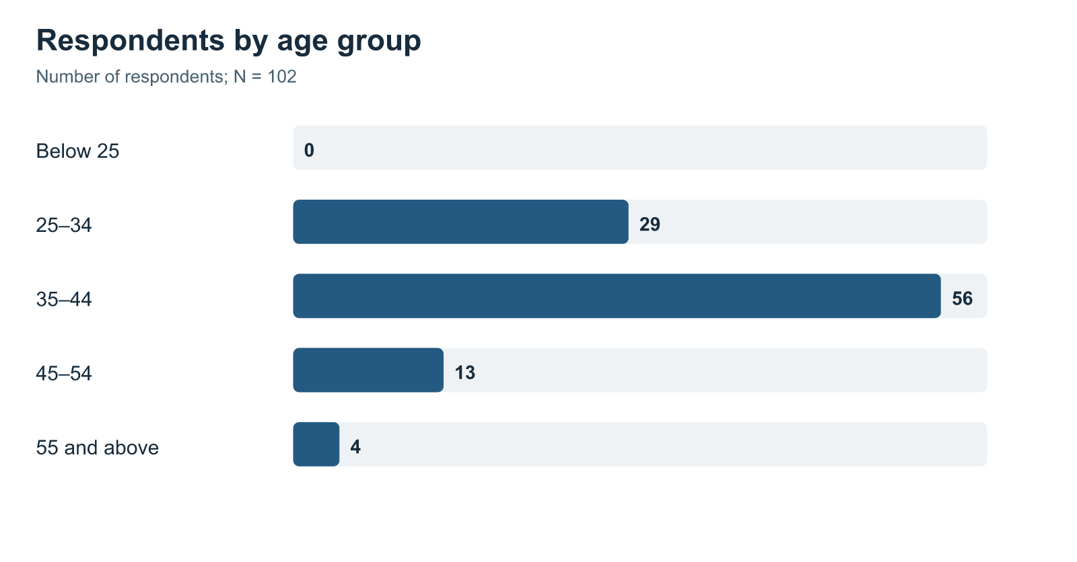
Figure 4.2: Length-of-service distribution
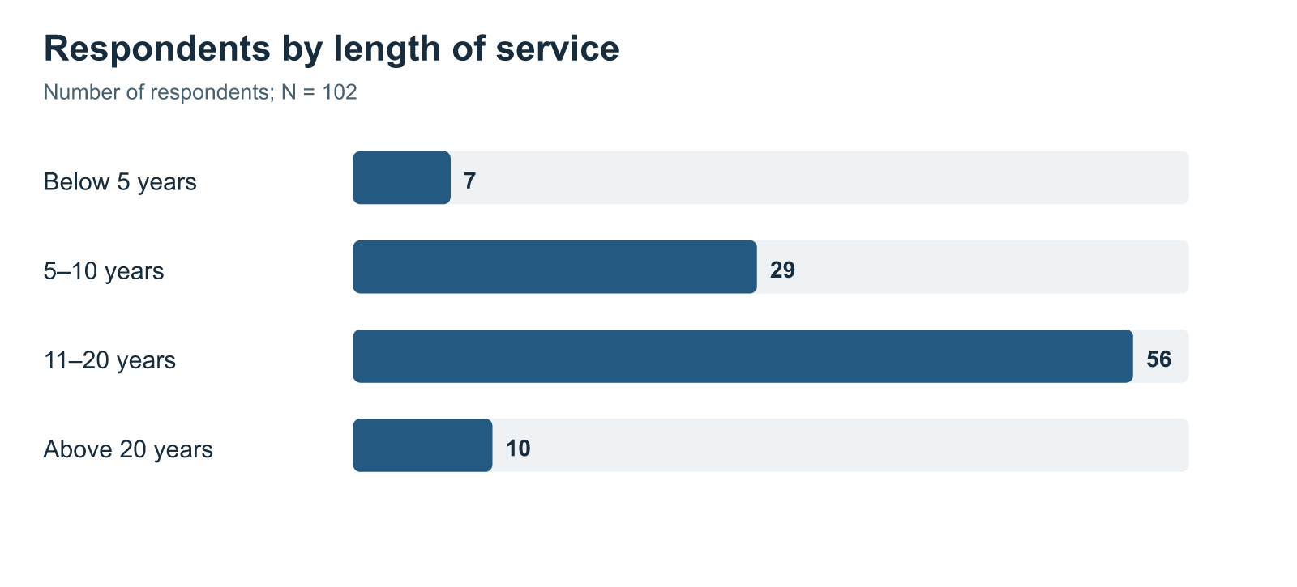
Figure 4.3: Job-level distribution
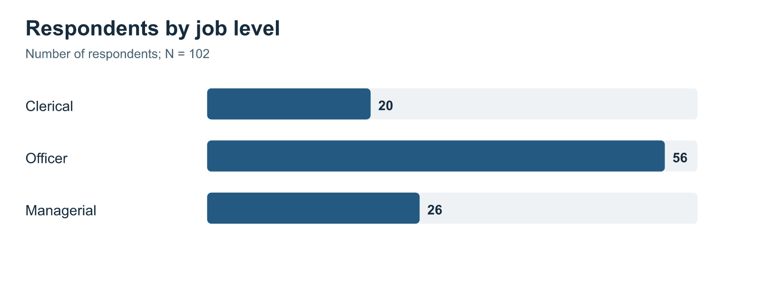

4.1.1 Construct-Level Results
The SPSS Explore results show that the mean scores for all four constructs are above the midpoint of the five-point scale, with Learner Engagement coming highest, followed by Training Effectiveness, Trainer Competence, and Hybrid Learning.
Table 4.2: Construct-level descriptive statistics from SPSS Explore output
Construct | Valid N | Mean | Standard deviation | Minimum | Maximum | Skewness | Kurtosis
Hybrid Learning | 102 | 4.148 | 0.859 | 1.000 | 5.000 | -1.818 | 4.058
Trainer Competence | 102 | 4.158 | 0.863 | 1.000 | 5.000 | -2.109 | 5.583
Learner Engagement | 102 | 4.317 | 0.793 | 1.000 | 5.000 | -2.131 | 6.236
Training Effectiveness | 102 | 4.254 | 0.835 | 1.000 | 5.000 | -2.035 | 5.275

Source: Supplied SPSS Statistics 23 output, Explore procedure.
Figure 4.4: Mean ratings for the four study constructs
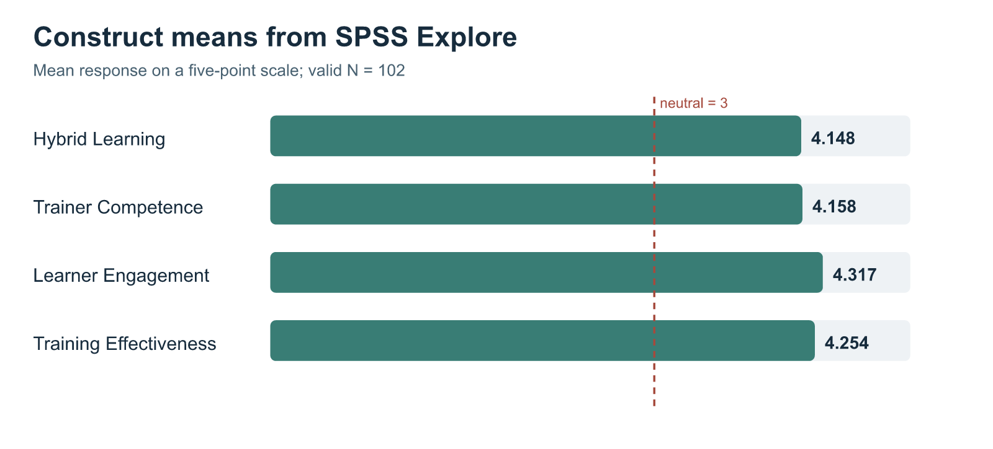
Source: Code-drawn figure from the four SPSS Explore means in Table 4.2; the dashed line marks the neutral response value of 3.
Inference: Agreement and strong agreement are the most common responses, which is the reason for the negative skewness shown in Table 4.2; while low ratings were not very frequent, the survey does not provide an explanation for this pattern.
Hybrid Learning scores the lowest yet are still above the neutral level; although employees as a whole rated the combined system in a favourable way, the practical aspects of it might deserve more scrutiny than those in the other areas. Learner Engagement is the highest, which is in line with the respondents' reports of their attention, participation, and interest.

4.1.2 Item-Level Results Across the Four Constructs
The seven Hybrid Learning items address connection across modes and access to digital material. Table 4.3 gives their SPSS item means for 103 available responses; Table 4.2 uses 102 cases with all four construct means.
Table 4.3: Hybrid Learning item means
Question | Item focus | Valid N | Mean
Q5 | Digital and face-to-face parts planned as one experience | 103 | 4.107
Q6 | Digital activities prepared the respondent for face-to-face sessions | 103 | 3.990
Q7 | Face-to-face sessions clarified or applied digital learning | 103 | 4.165
Q8 | Access to the digital platform | 103 | 4.184
Q9 | Ease of platform navigation | 103 | 4.107
Q10 | Availability of digital learning materials | 103 | 4.223
Q11 | Access to digital material for revision | 103 | 4.262

Source: SPSS Statistics 23 item descriptives; item wording is given in Appendix A.
Inference: Q6, about digital preparation for face-to-face sessions, has the lowest Hybrid Learning item mean at 3.990. This is still above neutral, but preparation is a reasonable part of the sequence for training staff to review.
Table 4.4 shows how the selected 102 records are distributed across all five response categories for each scored question; every row totals 102. These CSV counts are separate from the 103-case SPSS item means in Table 4.3. Figures 4.5–4.8 use the same counts as Table 4.4.
Table 4.4: Item response frequencies for the 102-case scored dataset
Construct | Question | 1 Strongly disagree | 2 Disagree | 3 Neutral | 4 Agree | 5 Strongly agree
Hybrid Learning | Q5 | 4 | 4 | 6 | 51 | 37
Hybrid Learning | Q6 | 3 | 5 | 13 | 51 | 30
Hybrid Learning | Q7 | 4 | 2 | 9 | 45 | 42
Hybrid Learning | Q8 | 3 | 3 | 7 | 49 | 40
Hybrid Learning | Q9 | 5 | 3 | 8 | 46 | 40
Hybrid Learning | Q10 | 4 | 2 | 6 | 45 | 45
Hybrid Learning | Q11 | 4 | 1 | 5 | 48 | 44
Trainer Competence | Q12 | 4 | 1 | 6 | 51 | 40
Trainer Competence | Q13 | 5 | 0 | 5 | 49 | 43
Trainer Competence | Q14 | 4 | 1 | 10 | 53 | 34
Trainer Competence | Q15 | 4 | 2 | 7 | 51 | 38
Trainer Competence | Q16 | 4 | 1 | 6 | 50 | 41
Trainer Competence | Q17 | 5 | 3 | 6 | 53 | 35
Learner Engagement | Q18 | 3 | 4 | 4 | 41 | 50
Learner Engagement | Q19 | 3 | 2 | 5 | 42 | 50
Learner Engagement | Q20 | 3 | 1 | 5 | 47 | 46
Learner Engagement | Q21 | 2 | 0 | 7 | 42 | 51
Learner Engagement | Q22 | 3 | 0 | 11 | 41 | 47
Learner Engagement | Q23 | 4 | 0 | 5 | 38 | 55
Training Effectiveness | Q24 | 4 | 0 | 5 | 48 | 45
Training Effectiveness | Q25 | 3 | 1 | 9 | 40 | 49
Training Effectiveness | Q26 | 3 | 0 | 10 | 45 | 44
Training Effectiveness | Q27 | 4 | 0 | 9 | 43 | 46
Training Effectiveness | Q28 | 3 | 2 | 8 | 43 | 46
Training Effectiveness | Q29 | 4 | 1 | 9 | 48 | 40
Training Effectiveness | Q30 | 3 | 2 | 10 | 32 | 55

Source: Reconstructed 102-case scored CSV; normal 1–5 response categories only.
Figure 4.5: Hybrid Learning item-response distribution
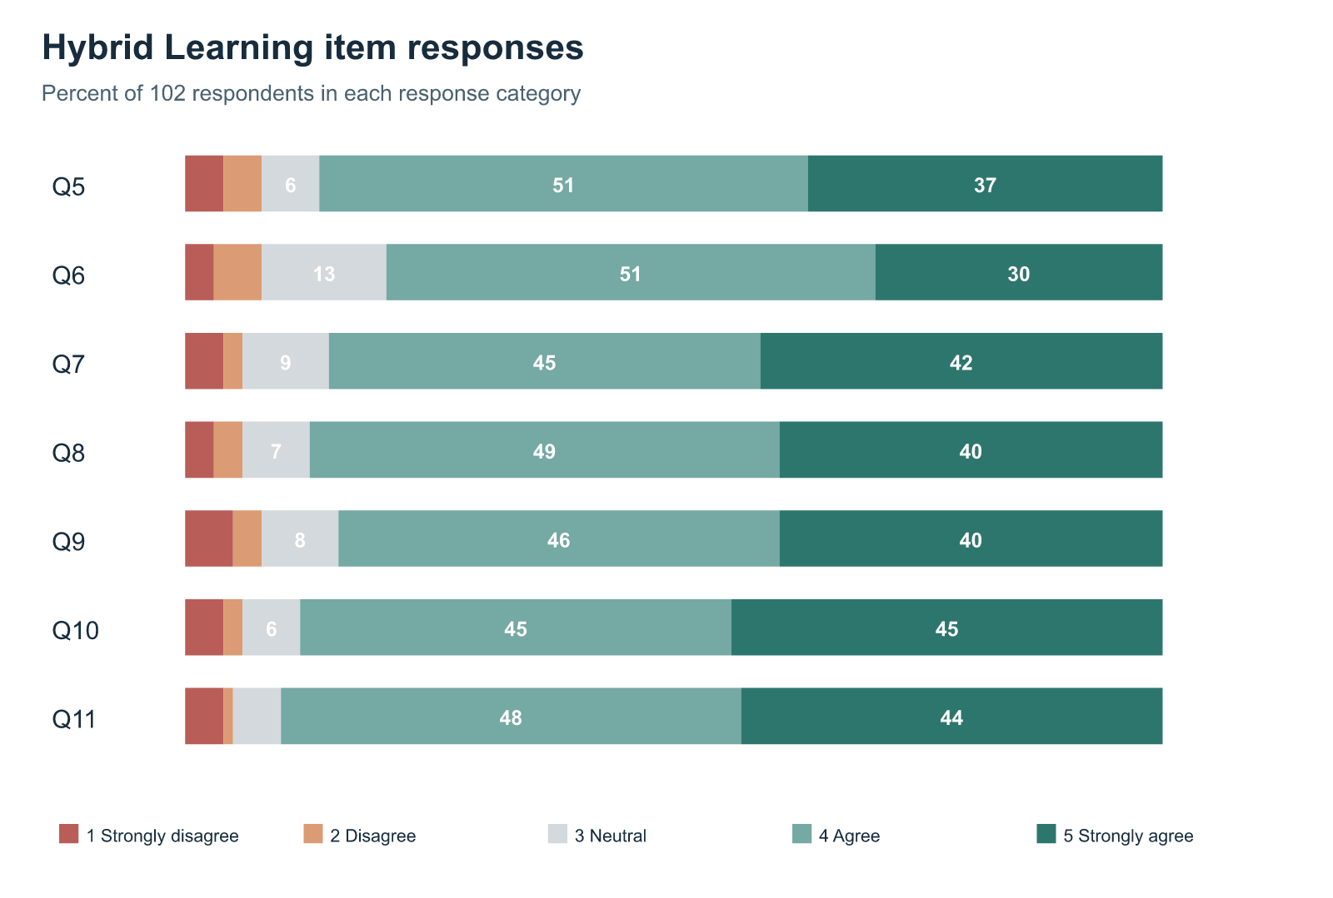
Figure 4.6: Trainer Competence item-response distribution
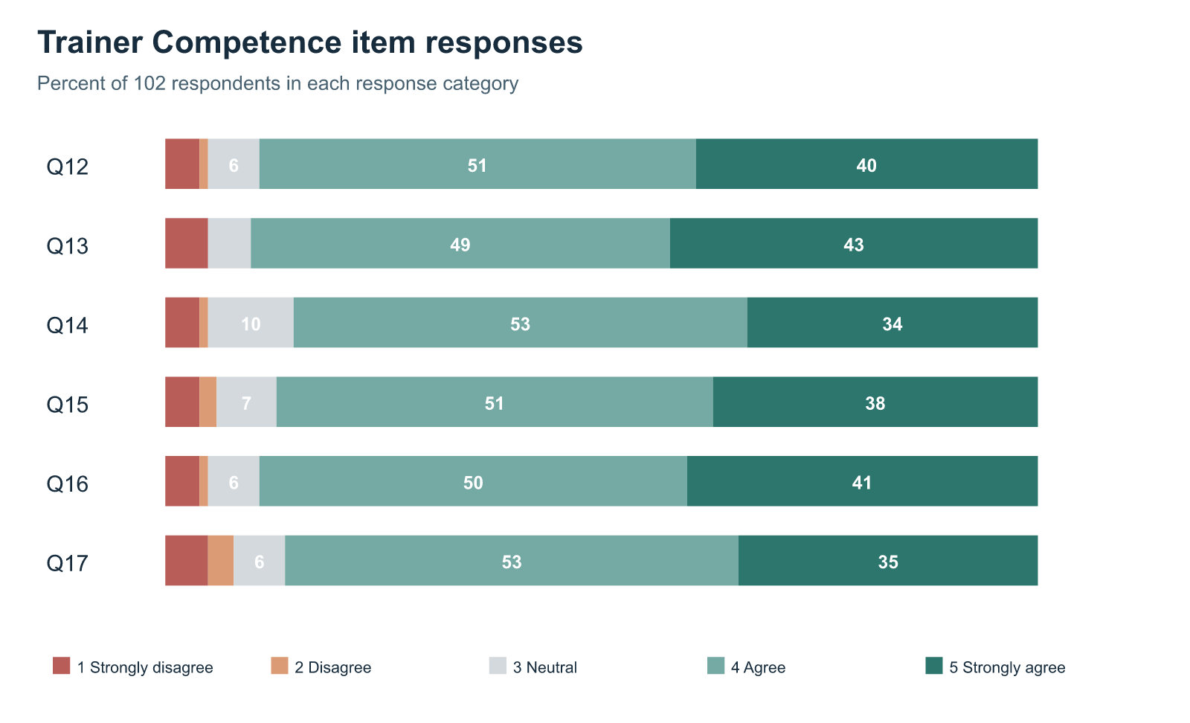
Figure 4.7: Learner Engagement item-response distribution
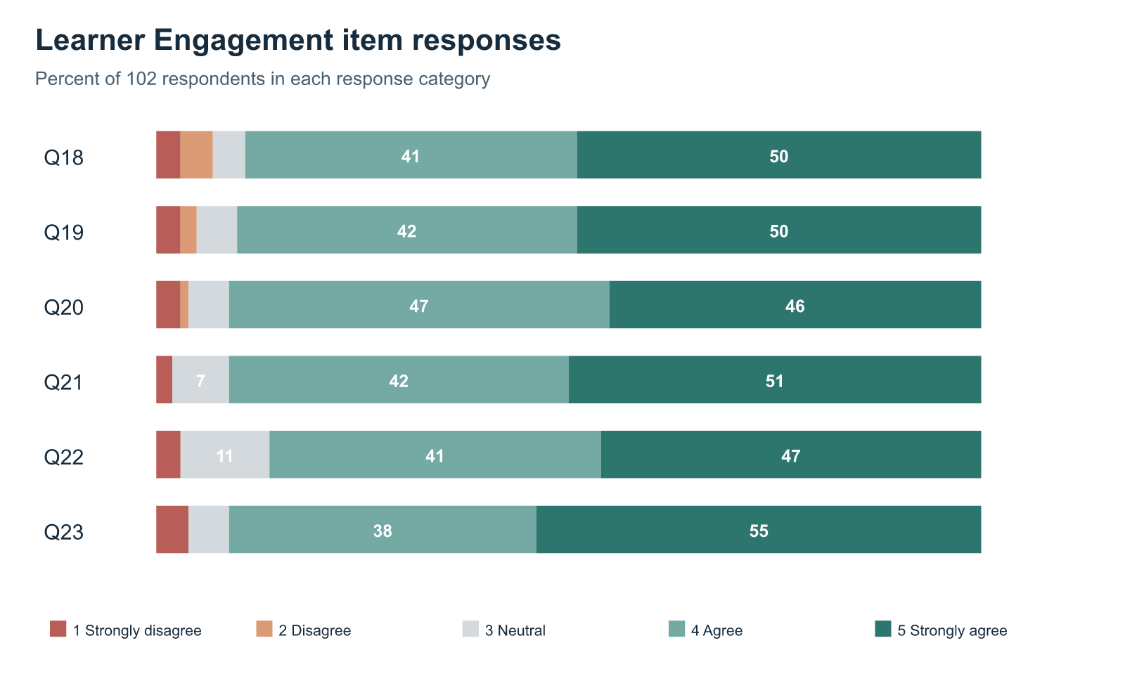
Figure 4.8: Training Effectiveness item-response distribution
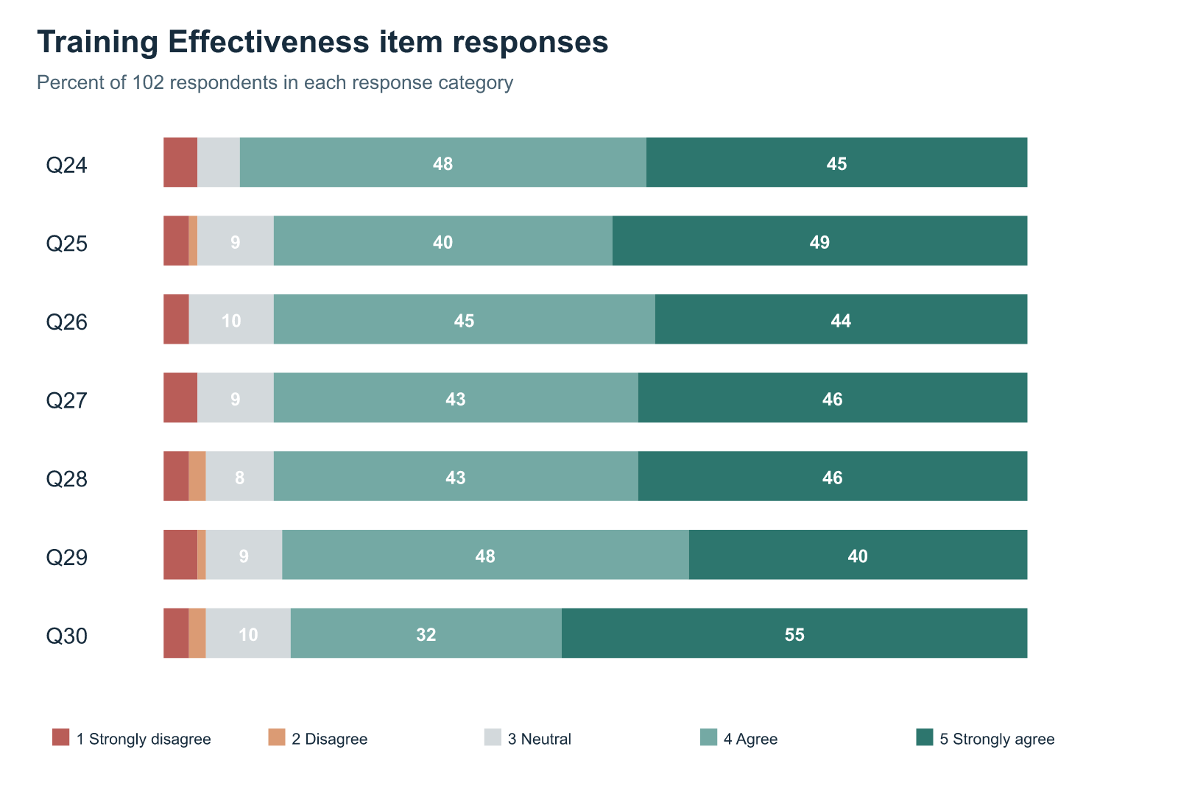

Trainer Competence responses
Trainer ratings were mostly favourable. Of the 102 respondents, 92 agreed or strongly agreed that the trainer explained content clearly (Q13), and 91 rated subject knowledge in those categories (Q12). The figures describe the support given by a person, which the presence of online material alone cannot capture.
The pattern is a little less favourable for connections across modes and feedback. On Q14, 87 agreed or strongly agreed that the trainer explained the link between activities, while ten were neutral. On Q17, 88 reported helpful feedback and eight disagreed or strongly disagreed. These modest item differences were not significance-tested, but they suggest checking how trainers refer to digital preparation and how feedback helps employees correct misunderstandings.

Learner Engagement responses
Engagement ratings were positive across attention, effort, participation, involvement, questions, and interest. On each of Q20, Q21, and Q23, 93 of 102 respondents selected agree or strongly agree. This is consistent with Learner Engagement having the highest construct mean: most described active involvement in the programme they chose.
Question-seeking showed a slightly different pattern. On Q22, 88 respondents agreed or strongly agreed that they sought clarification, while eleven were neutral. Neutral could mean no clarification was needed, no opening was available, or the employee hesitated. Since the questionnaire cannot separate those possibilities, the practical question is whether programmes make it easy to ask.
Positive trainer and engagement ratings appear in the same sample, but they describe different experiences. One concerns support offered; the other concerns what employees say they did. The regression examines whether the latter retains a distinct association with Training Effectiveness alongside trainer competence and hybrid design.

Training Effectiveness responses
Training Effectiveness items cover understanding, relevance, capability, application, task support, and confidence. In Figure 4.8, 93 respondents agreed or strongly agreed that they understood the main knowledge or skills (Q24). The count is 89 for each of Q25–Q28. These are employees’ own reports of learning and possible use, not supervisor observations of performance.
In Q29, 88 people said that training had enabled them to deal with relevant tasks or problems more effectively—that being five less than the number of favourable responses given in Q24 regarding understanding the content. Although this difference was not subject to a significance test, it does explain why questions about understanding and about the application of that understanding are asked separately. With respect to Q30, 87 respondents gave favourable answers and ten gave neutral ones regarding their confidence in carrying out their responsibilities; confidence is still a matter of perception and not a measured improvement in job performance.
In Figures 4.5 through 4.8, agreement is frequent but not universal. It is important to take into account neutral and negative responses since a high average score may mask a different experience for certain employees. The item counts show which options the respondents chose, not the reasons for their choices; therefore any actions suggested on the basis of them require further examination.

4.1.3 Distribution Diagnostics
Histograms, normal Q–Q plots and boxplots produced by SPSS display the distributions of the four constructs; alongside the regression are the residual plots. The negative skewness mentioned in Table 4.2 is due to the fact that the ratings are concentrated at the higher end of the scale.
For all four construct means the normality tests are significant, an outcome that is in keeping with the skewed distributions. The five-point scale has fixed limits and a large number of respondents selected the positive categories; this is important when interpreting the regression.

4.1.4 Overall Questionnaire Consistency and Exploratory Structure Check
A single SPSS reliability analysis includes all 26 scored questions and makes use of 102 valid cases while excluding one case.
Table 4.5: Overall questionnaire consistency
Item set | Number of items | Valid cases | Excluded cases | Cronbach’s alpha
All scored questionnaire items | 26 | 102 | 1 | .980

Source: Supplied SPSS Statistics 23 reliability output.
Inference: The .980 alpha shows a very high degree of consistency throughout the combined item set; it is not possible to obtain four construct-specific values since only the combined version is available. Moreover, questions that are closely related may also be responsible for this high figure and for the associations between the constructs measured on the same form.
An exploratory Principal Component Analysis used varimax rotation. The Kaiser–Meyer–Olkin value is .929; Bartlett’s test is significant, χ²(325) = 3664.340, p < .001; and SPSS extracted four components. These figures provide a structural diagnostic for an instrument designed around four theory-based constructs. They do not establish full scale validation or change the study model.

4.2 Inferential Analysis

4.2.1 Correlation Analysis
Pearson’s r shows the direction and strength of each pairwise relationship. Every correlation in Table 4.6 is positive and statistically significant.
Table 4.6: Pearson correlations among study constructs
Pair of constructs | Pearson’s r | Valid N | Significance
Hybrid Learning and Trainer Competence | .818 | 102 | < .001
Hybrid Learning and Learner Engagement | .713 | 103 | < .001
Hybrid Learning and Training Effectiveness | .659 | 103 | < .001
Trainer Competence and Learner Engagement | .746 | 102 | < .001
Trainer Competence and Training Effectiveness | .668 | 102 | < .001
Learner Engagement and Training Effectiveness | .765 | 103 | < .001

Source: Supplied SPSS Statistics 23 correlation output.
Inference: Learner Engagement has the strongest pairwise relationship with Training Effectiveness (r = .765): respondents who rated their participation more highly also tended to rate effectiveness more highly. Hybrid Learning and Trainer Competence are strongly related to each other (r = .818). Their overlap matters when interpreting the separate regression coefficients.

4.2.2 Multiple Regression Analysis
The main hypothesis uses multiple regression, with Training Effectiveness as the outcome and the other three constructs entered together as predictors.
Table 4.7: Overall multiple-regression model
R | R² | Adjusted R² | Standard error of estimate | F | df | Significance
.780 | .608 | .596 | .531 | 50.652 | 3, 98 | < .001

Source: Supplied SPSS Statistics 23 regression output; dependent variable: Training Effectiveness; valid N = 102.
Inference: The model is significant, F(3, 98) = 50.652, p < .001. Its three predictors together account for 60.8 per cent of the variation in reported Training Effectiveness among the 102 cases. This supports the overall alternative hypothesis.
Table 4.8: Predictor coefficients for Training Effectiveness
Predictor | Unstandardised B | Standard error | Standardised beta | t | Significance
Constant | .599 | .301 | — | 1.991 | .049
Hybrid Learning | .188 | .112 | .194 | 1.681 | .096
Trainer Competence | .109 | .115 | .113 | .947 | .346
Learner Engagement | .560 | .105 | .532 | 5.346 | < .001

Source: Supplied SPSS Statistics 23 regression coefficients table; dependent variable: Training Effectiveness; valid N = 102.
Inference: When all three predictors are included in the model, the only one that has a significantly different coefficient is Learner Engagement (β = .532, p < .001). Once the overlap with Hybrid Learning and Trainer Competence is taken into account, higher engagement ratings are associated with higher effectiveness ratings.
In this combined model, both Hybrid Learning and Trainer Competence have positive but not significant individual coefficients; the pairwise correlations between them remain positive, including a strong correlation between the two variables. Among the respondents, Learner Engagement displays the most distinct statistical association when all three variables are included, and therefore the other two should not be considered unimportant on that ground.
VIF and tolerance were not reported in the saved regression output. The interpretation therefore acknowledges the strong Hybrid Learning–Trainer Competence correlation shown in Table 4.6.

4.2.3 Supplementary Comparisons and Test Suitability
The following supplementary tests make use of the 102-case scored CSV and address questions other than those in the main regression; they are exploratory in nature and do not allow for any causal interpretation. Although the saved SPSS viewer usually employed 103 cases for its additional tests, the data file could not be obtained for a cell-by-cell comparison. For this reason, the supplementary figures still need to be verified by SPSS before they are finally submitted.
The one-sample t-tests compare each construct mean with the neutral value of 3; all of the means are found to be higher, thus restating the positive descriptive pattern rather than testing the relationship hypothesis.
Table 4.9: One-sample comparisons with the neutral midpoint, 102-case scored CSV
Construct | N | Mean | t(101) | Significance
Hybrid Learning | 102 | 4.144 | 13.484 | < .001
Trainer Competence | 102 | 4.158 | 13.551 | < .001
Learner Engagement | 102 | 4.317 | 16.778 | < .001
Training Effectiveness | 102 | 4.254 | 15.159 | < .001

Hybrid Learning averages 4.144 in this CSV subset and 4.148 in the supplied SPSS Explore table. The difference means the two sources have not been shown to contain identical item values. Tables 4.2–4.7 and the hypothesis decision continue to follow the saved SPSS figures.
The comparison carried out by Welch involved 56 officers (mean = 4.163) and 26 managers (mean = 4.220); the values for Training Effectiveness did not differ significantly, t(52.261) = −0.270, p = .788; clerical staff were not included in this test of the two groups.
The paired t-tests involve comparing each respondent's effectiveness score with their scores on the other constructs. None of the three mean differences reaches the .05 level, and the comparisons are between different concepts on the same survey rather than involving changes over time.
Table 4.10: Paired comparisons with Training Effectiveness, 102-case scored CSV
Paired scores | Mean difference | t(101) | Significance
Hybrid Learning − Training Effectiveness | −0.109 | −1.611 | .110
Trainer Competence − Training Effectiveness | −0.095 | −1.385 | .169
Learner Engagement − Training Effectiveness | 0.063 | 1.126 | .263

The one-way ANOVA involves the clerical (M = 4.550, n = 20), officer (M = 4.163, n = 56), and managerial (M = 4.220, n = 26) respondents; the differences found are not significant, F(2, 99) = 1.629, p = .201, and as a result a Duncan post-hoc comparison is not carried out in order to assert the presence of distinct groups in the analysis of the 102 cases.
The Pearson chi-square test cannot be relied upon since the raw-cross-tabulations are too sparse. In all three of the tables showing the predictors against effectiveness, 98.8 to 99.3 per cent of the expected cells are below five, the lowest expected frequency being near .010. The pairwise relationships between the constructs are therefore assessed by means of the correlations given in Table 4.6.
Table 4.11: Chi-square crosstab suitability check, 102-case scored CSV
Construct crossed with Training Effectiveness | Pearson χ² | df | Expected cells below 5 | Interpretation
Hybrid Learning | 433.554 | 266 | 99.3% | Too sparse for inference
Trainer Competence | 369.492 | 196 | 99.1% | Too sparse for inference
Learner Engagement | 481.111 | 210 | 98.8% | Too sparse for inference

The possible values of the construct are numerous and result in extremely small expected frequencies. Decisions about any hypothesis are not based on these chi-square statistics.

4.3 Interpretation of Results
Employees who said that they had taken a more active part in the programme also gave higher ratings to the relevance, their confidence, and the way the material could be applied to their work. For bank employees, being involved could involve attending the session in a close manner, asking questions, carrying out a procedure, or going back to the material when a task came up.
Hybrid Learning received a positive rating and was linked with Training Effectiveness, but question six indicates a somewhat weaker aspect in that the digital activities did not prepare the respondents for the subsequent face-to-face session to the same extent as the other items within Hybrid Learning had been rated. Although time or guidance may have been the cause, the survey is unable to determine it and thus highlights preparation as an area that should be reviewed.
Correlation indicates that each of the predictors is positively related to Training Effectiveness. Regression then investigates whether the association remains clear when the other predictors are included in the model; by this more specific test, Learner Engagement emerges as the standout factor.

4.4 Comparison with Previous Studies
Sosnova et al. (2025) studied hybrid methods and learning outcomes among students. The Union Bank respondents also rated connected learning positively, but the populations, measures, and designs differ. No classroom-only comparison group was surveyed here.
Kim’s (2022) automotive study directs attention to delivery, instructors, and design, while showing that hybrid delivery did not outperform traditional training in every comparison. Here, Hybrid Learning and Trainer Competence both correlate positively with Training Effectiveness, but Learner Engagement has the clearest coefficient in the combined model. This bank survey concerns employee perceptions of one programme, not Kim’s comparison of delivery formats.
Bahl, Kiran and Sharma (2024) evaluate bank training through Kirkpatrick’s levels. The current evidence is narrower: respondents report understanding, relevance, and perceived use of learning, without objective performance or organisation-level results. Mulaudzi’s (2021) account of workplace access and practical barriers gives a reason to look more closely at the lower digital-preparation rating in Table 4.3.
The item counts illustrate the distinction between learning and application: 93 respondents rated understanding favourably on Q24, compared with 88 who reported better handling of tasks or problems on Q29. The difference is small and untested, yet the questions address different outcomes. Kirkpatrick and transfer research explain why understanding is not itself proof of sustained work behaviour; this survey records a one-time employee account.
Han and Ellis (2020) look at the way learners experience a blended environment; question six provides an example from the workplace showing why this is important, since, although Hybrid Learning as a whole was rated positively, the preparation given before the face-to-face session obtained the lowest item mean within that section. Yet the question is relevant to training in banks without considering the student instrument to have been validated for use with bank employees.

4.5 Theoretical and Practical Implications
Programme design, support provided by trainers, and employee involvement each have a significant pairwise relationship with perceived Training Effectiveness. These correlations should not be read as separate adjusted effects. The cross-sectional results also give no evidence of a causal order among the factors.
The most clear-cut practical suggestion concerns the transition from digital preparation to the actual session. The coordinators should be able to find out when the material reaches the employees, whether the work schedules provide them with enough time to make use of it, and how the trainers build on it. It should be possible to ask questions and carry out practice during the session. Although questions in Q6 and the engagement association support these proposals, the survey did not test the proposed changes.
The preparation, the session, and the subsequent revision can be regarded as a single sequence. Employees should be given a well-defined digital task along with the necessary time to carry it out. The trainer should link this task to an example from the banking sector and then invite questions. After the session, readily available material should be provided so that the staff can go over the topic whenever it is needed in their work. The questionnaire includes all these stages; however, a further evaluation would be required to determine if modifying them has a positive effect on the outcomes.

CHAPTER - 5
SUMMARY, CONCLUSION AND SUGGESTIONS

CHAPTER 5 — SUMMARY, CONCLUSION AND SUGGESTIONS

5.1 Introduction
The chapter sets out the implications of the findings for the group of respondents from Union Bank. The independent variables are Hybrid Learning, Trainer Competence, and Learner Engagement, while Training Effectiveness is the dependent variable. The regression is based on 102 valid cases.

5.2 Summary of the Study
Union Bank gives its employees training via physical facilities and with the help of digital support, such as Union Vidya and virtual delivery; a programme can therefore include online material, trainer-led discussions, practical exercises, questions, and resources for later use.
The study focused on four constructs:
• Hybrid Learning;
• Trainer Competence;
• Learner Engagement; and
• Training Effectiveness.
Respondents considered one hybrid programme attended in the previous 12 months. The questionnaire contained four eligibility and profile questions and 26 five-point agreement items. A separate online pilot ran from 15 to 16 September 2026 while main collection began on 15 September. It checked clarity, relevance, repetition, completion burden, and Union Vidya wording; pilot responses were excluded from the main analysis.
The paper forms and the Google Forms resulted in 132 main submissions from employees who were associated with the Regional Office Chennai South and with certain branches. After screening, 103 profile-completed records remained. SPSS reported 102 valid cases for use at the construct level and for the regression analysis since one of the Trainer Competence means was missing from its file.
The hypothesis in question is whether the three independent variables together have the ability to predict Training Effectiveness. The SPSS output that has been saved contains the descriptive statistics, one overall reliability analysis, an exploratory factor analysis, the correlation coefficients, and the results of the multiple regression. It is the regression analysis that determines the decision regarding the hypothesis.

5.3 Major Findings

5.3.1 Respondents rated all four areas positively
All the scores were above the midpoint of the scale. The highest score was for Learner Engagement (4.317), then came Training Effectiveness (4.254), followed by Trainer Competence (4.158), and last of all Hybrid Learning (4.148). Therefore, the majority of the respondents offered positive evaluations of the programme in question.
Hybrid Learning stayed positive but placed at the bottom. Mixing use of a platform with face-to-face sessions might leave employees wishing for more thorough preparation or for the material to be more closely linked to the trainer-led activities.

5.3.2 The four constructs were positively associated
All the pairwise Pearson correlations were positive and significant; Learner Engagement showed the strongest relationship with Training Effectiveness (r = .765), and Hybrid Learning was also strongly related to Trainer Competence (r = .818). Often, the respondents gave similar ratings to the various parts of the training.

5.3.3 Decision on the study hypothesis
There is a single general hypothesis concerning the three predictors considered together. The regression reaches significance at the 5 per cent level. The null hypothesis (H₀) is rejected and the alternative hypothesis (H₁) is supported in the case of the combined model.
Table 5.1: Decision on the overall regression hypothesis
Test | Result | Decision
Hybrid Learning, Trainer Competence, and Learner Engagement jointly predicting Training Effectiveness | F(3, 98) = 50.652; p < .001; R² = .608; valid N = 102 | Reject H₀; support H₁ for the combined model.

The fact that the R² value is .608 shows that the predictors account for 60.8 per cent of the variation in the effectiveness ratings among these cases; it does not represent a percentage of learning or work performance caused by them.

5.3.4 Individual predictor results
The overall model need not have three significant individual coefficients, as Table 5.2 indicates which predictor maintains a clear association when the other two have been included in the regression.
Table 5.2: Individual predictors in the combined regression model
Predictor | Standardised beta | Significance | Result at the 5 per cent level
Hybrid Learning | .194 | .096 | Not individually significant
Trainer Competence | .113 | .346 | Not individually significant
Learner Engagement | .532 | < .001 | Individually significant

The aspect of learner engagement showed the most distinct unique relationship. Although the coefficients for hybrid learning and trainer competence were positive, neither of them was statistically significant when all three variables were included. Nonetheless, both of them still had a positive correlation with training effectiveness and were also strongly linked to one another. One cannot ignore their practical significance merely on the basis of these coefficients.
It is the combined model that makes the H₀/H₁ decision, not the three coefficient results, since the latter only explain it rather than present separate hypotheses.

5.4 Contribution of the Study
The study provides an account of the hybrid programme at Union Bank at the level of the employee; Union Vidya forms part of the delivery setup, whereas the model individually assesses programme experience, trainer support, participation, and perceived effectiveness. The fact that a platform exists is not regarded as an outcome.
A great deal of the literature on hybrid learning focuses on education, while the present survey puts the issue in the context of banking. Branch and office employees might have to carry out their training around deadlines, customer requirements, compliance obligations, and digital changes. Just as much attention should be paid to their own level of involvement as to the design of the training since this can show conditions that go beyond those of the platform or the trainer.
The fact that the four experiences are separated means that the findings become more specific than a general assessment of whether or not employees liked the training. Although all three predictors have a positive correlation with Training Effectiveness, only Learner Engagement has a significant individual coefficient in the overall model. This distinction should cause people to focus on preparation and participation when the programme is being reviewed.

5.5 Suggestions for Training Review
The two findings determine the priorities: in the combined regression Learner Engagement is the only factor that is individually significant, and digital preparation before face-to-face sessions is the lowest-rated item in the Hybrid Learning section (Q6, mean = 3.990; Table 4.3). The suggestions listed below are proposals for review and are not interventions that have been tested.
1. Make participation possible. A work-related case, demonstration, questions, and brief practice can give staff ways to use what they hear. Programme reviewers can check whether employees can actually take part instead of merely attending.
2. Allow time for digital preparation. Coordinators can check when staff receive materials, login details, and a clear task before the trainer-led session. This responds directly to the lower Q6 rating.
3. Show how the activities connect. The trainer can use a banking task to build on earlier digital material, then point employees to the resource they can revisit afterwards.
4. Fit training around branch work where possible. Customer service and workload can crowd out preparation and participation. Local scheduling should take that pressure into account.
5. Ask what needs attention. Short post-training feedback can separate problems with access, preparation, guidance, participation, and relevance. Staff can then review the part of the programme employees found difficult.
Table 5.3: How the findings inform the proposed training review
Evidence from this study | Area to review | Practical check
Learner Engagement is the only individually significant predictor in the combined model (β = .532, p < .001; N = 102). | Participation during training | Check whether employees have a realistic opportunity to ask, practise, and take part, rather than only attend or complete a module.
Digital preparation before the face-to-face session has the lowest Hybrid Learning item mean (Q6, 3.990; SPSS item N = 103). | Preparation before trainer-led learning | Check the timing, clarity, and work relevance of the material sent before a session.
Ten respondents were neutral about the trainer explaining the connection between modes (Q14; 102-case frequency table). | Connection between activities | Ask trainers to show explicitly how the earlier digital task relates to the live discussion or demonstration.
Eleven respondents were neutral about seeking clarification (Q22; 102-case frequency table). | Opportunities for questions | Check whether the programme gives employees a suitable way to ask questions in person or through the digital channel.
Eighty-eight respondents reported that training helped with relevant work tasks or problems (Q29; 102-case frequency table). | Application after training | Ask for specific examples of use and identify any support employees still need when they return to work.

The table connects reported patterns with areas worth examining. It does not show that the suggested changes have been tested or would improve training outcomes.
The first two rows carry the strongest evidence for review: engagement has the clearest adjusted relationship with effectiveness, and digital preparation has the lowest Hybrid Learning item mean. The remaining rows turn item ratings into questions to investigate. Most answers were still positive, so a few neutral responses should prompt enquiry rather than a claim of widespread failure.

5.6 Limitations of the Study
These findings concern the purposively selected Chennai South respondents, not a random sample of all Union Bank employees. One-time self-reports also leave time order and causation unknown.
Each person rated both the training experience and its perceived outcome, which may strengthen associations through a shared response method. The SPSS output has one high alpha for all 26 items, not four construct-specific estimates. One case lacked a Trainer Competence mean and was excluded listwise from the main model. The predictors also overlap substantially, especially Hybrid Learning and Trainer Competence; their individual coefficients need to be read with that overlap in mind.
Paper and online forms had identical wording, although response-mode differences were not tested. A formal response rate is unavailable because invitations and approaches were not counted completely. Supplementary 102-case item distributions come from scored records, whereas the main regression comes from the saved SPSS viewer. Without its matching case file, exact person-level agreement between the sources remains unverified. This limits how confidently all supplementary and SPSS outputs can be treated as one fully reconciled dataset, even though the saved output records the stated hypothesis result.

5.7 Directions for Future Research
Future work could include more Union Bank regions and compare programme types or job levels. Following employees after training would offer evidence about application over time. Supervisor observations or work-based indicators could complement employee ratings.
Workload, manager support, learning time, digital confidence, and prior experience also warrant study. None was measured here, yet each might help explain why equally well-designed training does not lead every employee to participate in the same way.
A later survey could record invitations, retain response mode without collecting names, and use one checked case file for every table. Asking shortly after training and again when employees have had a chance to use it would provide a better account of application. That design would also be more suitable for evaluating a specific change in training practice.

5.8 Conclusion
The overall null hypothesis is rejected for the 102 valid cases: the three predictors jointly relate to perceived Training Effectiveness, with R² = .608. The alternative hypothesis is supported for the combined model. Learner Engagement alone has a significant individual coefficient after the other predictors are included.
For Union Bank, the results point toward reviewing preparation and opportunities for active participation. Digital material and trainer-led work need a clear connection to employees’ tasks. These suggestions arise from the reported patterns; the analysis does not show that implementing them would cause better outcomes.

REFERENCES
Ansari, B. I., Junaidi, J., Maulina, S., Herman, H., Kamaruddin, I., Rahman, A., & Saputra, N. (2023). The effect of blended-learning training on lecturers’ and students’ competence and satisfaction. Journal of Intercultural Communication, 23(4), 155–164. https://doi.org/10.36923/jicc.v23i4.201
Aziz, S. F. A. (2015). Developing general training effectiveness scale for the Malaysian workplace learning. Mediterranean Journal of Social Sciences, 6(4S1), 47–56. https://doi.org/10.5901/mjss.2015.v6n4s1p47
Bahl, K., Kiran, R., & Sharma, A. (2024). Evaluating the effectiveness of training of managerial and non-managerial bank employees using Kirkpatrick’s model for evaluation of training. Humanities and Social Sciences Communications, 11, 508. https://doi.org/10.1057/s41599-024-02973-y
Baldwin, T. T., & Ford, J. K. (1988). Transfer of training: A review and directions for future research. Personnel Psychology, 41(1), 63–105. https://doi.org/10.1111/j.1744-6570.1988.tb00632.x
Blume, B. D., Ford, J. K., Baldwin, T. T., & Huang, J. L. (2010). Transfer of training: A meta-analytic review. Journal of Management, 36(4), 1065–1105. https://doi.org/10.1177/0149206309352880
Garrison, D. R., & Kanuka, H. (2004). Blended learning: Uncovering its transformative potential in higher education. The Internet and Higher Education, 7(2), 95–105. https://doi.org/10.1016/j.iheduc.2004.02.001
Graham, C. R. (2006). Blended learning systems: Definition, current trends, and future directions. In C. J. Bonk & C. R. Graham (Eds.), The handbook of blended learning (pp. 3–21). Pfeiffer.
Han, F., & Ellis, R. A. (2020). Initial development and validation of the Perceptions of the Blended Learning Environment Questionnaire. Journal of Psychoeducational Assessment, 38(1), 23–38. https://doi.org/10.1177/0734282919834091
Holton, E. F. (1996). The flawed four-level evaluation model. Human Resource Development Quarterly, 7(1), 5–21. https://doi.org/10.1002/hrdq.3920070103
Kim, S. (2022). Innovating workplace learning: Training methodology analysis based on content, instructional design, programmed learning, and recommendation framework. Frontiers in Psychology, 13, 870574. https://doi.org/10.3389/fpsyg.2022.870574
Kirkpatrick, D. L. (1994). Evaluating training programs: The four levels. Berrett-Koehler.
Kumar, R., & Pande, N. (2017). Technology-mediated learning paradigm and the blended learning ecosystem: What works for working professionals? Procedia Computer Science, 122, 1114–1123. https://doi.org/10.1016/j.procs.2017.11.446
Mubayrik, H. B. (2018). The present and future state of blended learning at workplace-learning settings in adult education: A systematic review. Journal of Social Studies Education Research, 9(4), 247–273.
Mulaudzi, M. S. (2021). The use of blended teaching to improve workplace training in the transport sector [Master’s dissertation, University of Johannesburg]. https://hdl.handle.net/10210/501896
Schaufeli, W. B., Bakker, A. B., & Salanova, M. (2006). The measurement of work engagement with a short questionnaire. Educational and Psychological Measurement, 66(4), 701–716. https://doi.org/10.1177/0013164405282471
Sosnova, M., Hlianenko, K., Sosnova, V., Tsyna, V., & Tsyna, A. (2025). Enhancing the effectiveness of learning through hybrid education methods. Revista Eduweb, 19(2), 95–106. https://doi.org/10.46502/issn.1856-7576/2025.19.02.7
Uddin, M., Ahamed, M. R., Jakowan, Islam, M. R., & Nahar, M. (2026). How blended learning influences employee performance: The mediating role of soft skill development and knowledge acquisition. International Journal of Accounting and Economics Studies, 13(2), 243–250. https://doi.org/10.14419/9cjynm83
Union Bank of India. (n.d.-a). About Union Bank of India. Retrieved September 22, 2026, from https://www.unionbankofindia.bank.in/en/common/profile
Union Bank of India. (n.d.-b). Address and contact details of training centres. Retrieved September 22, 2026, from https://www.unionbankofindia.bank.in/pdf/address%20and%20contact%20details%20of%20training%20centres.pdf
Union Bank of India. (2022, October 1). Union Bank of India launches 9 Union Learning Academies [Press release]. https://www.unionbankofindia.bank.in/pdf/union%20bank%20of%20india%20launches%209%20union%20learning%20academies.pdf
Union Bank of India. (2024). Integrated annual report 2023–24. https://www.unionbankofindia.bank.in/pdf/ubi-iar2024-final-stitched-book-english-compressed-26-06-2024.pdf
Union Bank of India. (2025). Integrated annual report 2024–25. https://www.unionbankofindia.bank.in/pdf/union-bank-ar-2024-25-eng-final.pdf
Union Bank of India. (2026, September 9). Live streaming of training sessions from training centres – Enhancing learning accessibility across the Bank [Staff circular, internal].
Vo, M. H., Zhu, C., & Diep, N. A. (2017). The effect of blended learning on student performance at course-level in higher education: A meta-analysis. Studies in Educational Evaluation, 53, 17–28. https://doi.org/10.1016/j.stueduc.2017.01.002
Yu, Q., Yu, K., Li, B., & Wang, Q. (2025). Effectiveness of blended learning on students’ learning performance: A meta-analysis. Journal of Research on Technology in Education, 57(3), 499–520. https://doi.org/10.1080/15391523.2023.2264984

APPENDIX

APPENDIX A — QUESTIONNAIRE

Hybrid Learning and Training Effectiveness at Union Bank of India
This questionnaire forms part of an academic study on hybrid learning and training effectiveness among employees of Union Bank of India.
In this study, hybrid learning means a training programme in which digital learning and face-to-face learning were planned as connected parts of the same programme. The digital component may have used Union Vidya, Union Bank of India’s Learning Management System (LMS), or another authorised learning platform.
Please answer the statements with reference to one hybrid-training programme attended during the last 12 months. There are no right or wrong answers. Participation is voluntary and confidential. Do not write your name, employee number, customer details, or any confidential Bank information.

Section A — Eligibility and Basic Information
1. During the last 12 months, have you attended a training programme that included both digital or online learning and face-to-face learning?
Yes / No
If your answer is No, please do not continue with the questionnaire.
2. Age group: Below 25 / 25–34 / 35–44 / 45–54 / 55 and above
3. Length of service in Union Bank of India: Below 5 years / 5–10 years / 11–20 years / Above 20 years
4. Job level: Clerical / Officer / Managerial / Other

Response Scale for Questions 5–30
1 – Strongly Disagree
2 – Disagree
3 – Neither Agree nor Disagree
4 – Agree
5 – Strongly Agree

Section B — Hybrid Learning
In Questions 5–11, “digital learning platform” means Union Vidya where it was used for your selected programme, or another authorised digital platform used for that programme.
5. The digital and face-to-face parts of the programme were planned as one connected learning experience.
6. The digital activities prepared me for the face-to-face sessions.
7. The face-to-face sessions helped me clarify or apply what I learned through the digital activities.
8. I could access the digital learning platform used for the programme without much difficulty.
9. The digital platform was easy for me to navigate while completing the training.
10. Learning materials on the digital platform were available when I needed them.
11. I could revisit digital modules or learning materials when I needed revision.

Section C — Trainer Competence
12. The trainer had good knowledge of the training subject.
13. The trainer explained the training content clearly.
14. The trainer explained how the digital and face-to-face activities were connected.
15. The trainer was able to use the digital tools involved in the programme effectively.
16. The trainer encouraged employees to ask questions and take part in activities.
17. The trainer gave feedback that helped me understand or improve my learning.

Section D — Learner Engagement
18. I stayed attentive during the training activities.
19. I made a serious effort to understand the training content.
20. I participated actively in discussions, exercises, or other training activities.
21. I felt involved in the learning process rather than simply completing required activities.
22. I asked questions or sought clarification when I did not understand something.
23. I remained interested in completing the programme.

Section E — Training Effectiveness
24. I understood the main knowledge or skills covered in the programme.
25. The training gave me knowledge or skills that are useful in my current role.
26. The content of the programme was relevant to the work I do at the Bank.
27. I feel capable of using the knowledge or skills taught in the programme.
28. I have applied learning from the programme in my day-to-day work.
29. The programme helped me deal with relevant work tasks or problems more effectively.
30. The programme has improved my confidence in carrying out relevant work responsibilities.

APPENDIX B — QUESTIONNAIRE DEVELOPMENT AND LITERATURE BASIS
The questionnaire was developed for employees to answer about one recent programme that combined digital and face-to-face learning. Tables B.1–B.4 show the concept addressed by each scored question, the literature that informed it, and the reason for its workplace wording. The cited papers support the question themes; the table does not assign an identical published scale item to every question. Questions 1–4 are eligibility and profile questions, so the tables begin with Question 5. Full references appear in the thesis reference list.
The three base papers have different roles in this development. Sosnova et al. (2025) support the broad connection between hybrid methods and learning effectiveness. Kim (2022) supplies corporate training evidence on delivery design, instructors, participation, and perceived outcomes. Bahl, Kiran and Sharma (2024) establish the relevance of training evaluation among Indian bank employees. The more specific item themes also draw on blended-learning environment, workplace learning, engagement, and training-transfer literature. Bahl’s paper is a banking-context source; it is not treated as an item bank for Hybrid Learning, Trainer Competence, or Learner Engagement.
Table B.1: Literature basis for Hybrid Learning questions
Question and focus | Literature basis | Adaptation for this study
Q5 — connection between digital and face-to-face parts | Garrison and Kanuka (2004); Graham (2006); Han and Ellis (2020) | Asks whether the respondent experienced one connected programme, rather than two unrelated activities.
Q6 — digital preparation before a face-to-face session | Han and Ellis (2020); Sosnova et al. (2025); Kim (2022) | Tests whether the earlier digital work had a clear preparatory role in the selected programme.
Q7 — clarification and application during face-to-face learning | Garrison and Kanuka (2004); Sosnova et al. (2025); Kim (2022) | Asks whether the trainer-led part helped the employee use or understand what was learned digitally.
Q8 — access to the programme’s digital platform | Mulaudzi (2021); Kumar and Pande (2017) | Refers to Union Vidya where used, or another authorised platform used for that programme.
Q9 — ease of navigating the platform | Mulaudzi (2021); Han and Ellis (2020) | Focuses on the employee’s ability to use the platform for learning; it is not a technical system audit.
Q10 — availability of digital learning material | Mulaudzi (2021); Han and Ellis (2020) | Asks whether required material was available when the employee needed it.
Q11 — access to material for later revision | Han and Ellis (2020); Mulaudzi (2021) | Captures whether the employee could return to the digital material after an initial activity.

Table B.2: Literature basis for Trainer Competence questions
Question and focus | Literature basis | Adaptation for this study
Q12 — trainer’s subject knowledge | Kim (2022); Ansari et al. (2023) | Asks about the trainer’s command of the topic in the selected programme.
Q13 — clarity of explanation | Kim (2022); Mulaudzi (2021) | Separates understandable explanation from simply making content available.
Q14 — explanation of the connection between modes | Kim (2022); Mulaudzi (2021) | Asks whether the trainer helped employees see how digital and face-to-face activities fitted together.
Q15 — effective use of digital tools | Kim (2022); Ansari et al. (2023) | Concerns the trainer’s use of tools during learning, not the platform’s technical performance.
Q16 — encouragement of questions and participation | Kim (2022); Mulaudzi (2021) | Measures support offered by the trainer, separately from whether the employee participated.
Q17 — useful feedback | Kim (2022); Mulaudzi (2021) | Asks whether feedback helped the employee understand or improve learning.

Table B.3: Literature basis for Learner Engagement questions
Question and focus | Literature basis | Adaptation for this study
Q18 — attention during training | Schaufeli, Bakker and Salanova (2006); Kim (2022) | Applies the general idea of active involvement to one selected training programme.
Q19 — effort to understand | Schaufeli, Bakker and Salanova (2006); Mulaudzi (2021) | Asks about the employee’s own effort rather than trainer behaviour or attendance.
Q20 — active participation | Kim (2022); Mulaudzi (2021) | Refers to discussions, exercises, or other activities available in the programme.
Q21 — involvement beyond required completion | Schaufeli, Bakker and Salanova (2006); Kim (2022) | Distinguishes feeling involved from merely finishing a required activity.
Q22 — seeking clarification | Kim (2022); Mulaudzi (2021) | Asks whether the employee acted when something was not understood.
Q23 — interest in completing the programme | Schaufeli, Bakker and Salanova (2006); Mulaudzi (2021) | Keeps interest tied to the selected programme, not general work engagement.

Table B.4: Literature basis for Training Effectiveness questions
Question and focus | Literature basis | Adaptation for this study
Q24 — understanding the main knowledge or skills | Kirkpatrick (1994); Kim (2022); Aziz (2015) | Measures employee-reported learning rather than satisfaction with attending.
Q25 — usefulness for the current role | Kim (2022); Aziz (2015) | Connects what was learned to the respondent’s present responsibilities.
Q26 — relevance of content to Bank work | Aziz (2015); Bahl, Kiran and Sharma (2024) | Places perceived training relevance in an employee and banking context; Bahl supports the context, not this exact item.
Q27 — perceived capability to use learning | Kim (2022); Aziz (2015) | Asks whether the employee feels capable of using the material, without claiming observed performance.
Q28 — reported application in day-to-day work | Baldwin and Ford (1988); Blume et al. (2010); Aziz (2015) | Captures the employee’s account of application, not independently verified transfer.
Q29 — support for work tasks or problems | Aziz (2015); Bahl, Kiran and Sharma (2024); Blume et al. (2010) | Links reported learning to relevant tasks; the banking paper supports evaluation in this setting rather than the exact wording.
Q30 — confidence in relevant responsibilities | Kim (2022); Aziz (2015) | Asks about perceived confidence after the programme, not a measured change in job performance.

The item map preserves the distinction between four constructs. Platform access and learning-mode integration belong to Hybrid Learning; trainer actions belong to Trainer Competence; the employee’s participation belongs to Learner Engagement; and reported learning and work application belong to Training Effectiveness. The pilot and the main-sample reliability results are discussed in Chapter 3. This appendix documents content development and does not by itself establish full validation of the instrument.

